Page 1 of 32
Report No.: LCSA022723066E001
FCC SDoC TEST REPORT
Shenzhen Damin Energy Technology Co., Ltd
Jump Starter
Test Model: CAT797
Prepared for
Address
: Shenzhen Damin Energy Technology Co., Ltd
: B717, Tang Shang Building, No. 35 Xinqiao Section of
Guangshen Road, Shangxing Community, Xinqiao
Street, Baoan District, Shenzhen City, Guangdong
Province, China
Prepared by
Address
: Shenzhen LCS Compliance Testing Laboratory Ltd.
: Room 101, 201, Building A and Room 301, Building C,
Juji Industrial Park, Yabianxueziwei, Shajing Street,
Bao’an District, Shenzhen, Guangdong, China
: (+86)755-82591330
Tel
Fax
Web
Mail
: (+86)755-82591332
: www.LCS-cert.com
: webmaster@LCS-cert.com
Date of receipt of test sample : February 28, 2023
Number of tested samples
Sample No.
: 1
: A022723066
Date of Test
Date of Report
: February 28, 2023 ~ April 20, 2023
: March 28, 2024
Shenzhen LCS Compliance Testing Laboratory Ltd.
Add: Room 101, 201, Building A and Room 301, Building C, Juji Industrial Park, Yabianxueziwei, Shajing Street,
Bao'an District, Shenzhen, Guangdong, China
Tel: +(86) 0755-82591330 | E-mail: webmaster@lcs-cert.com | Web: www.lcs-cert.com
Scan code to check authenticity
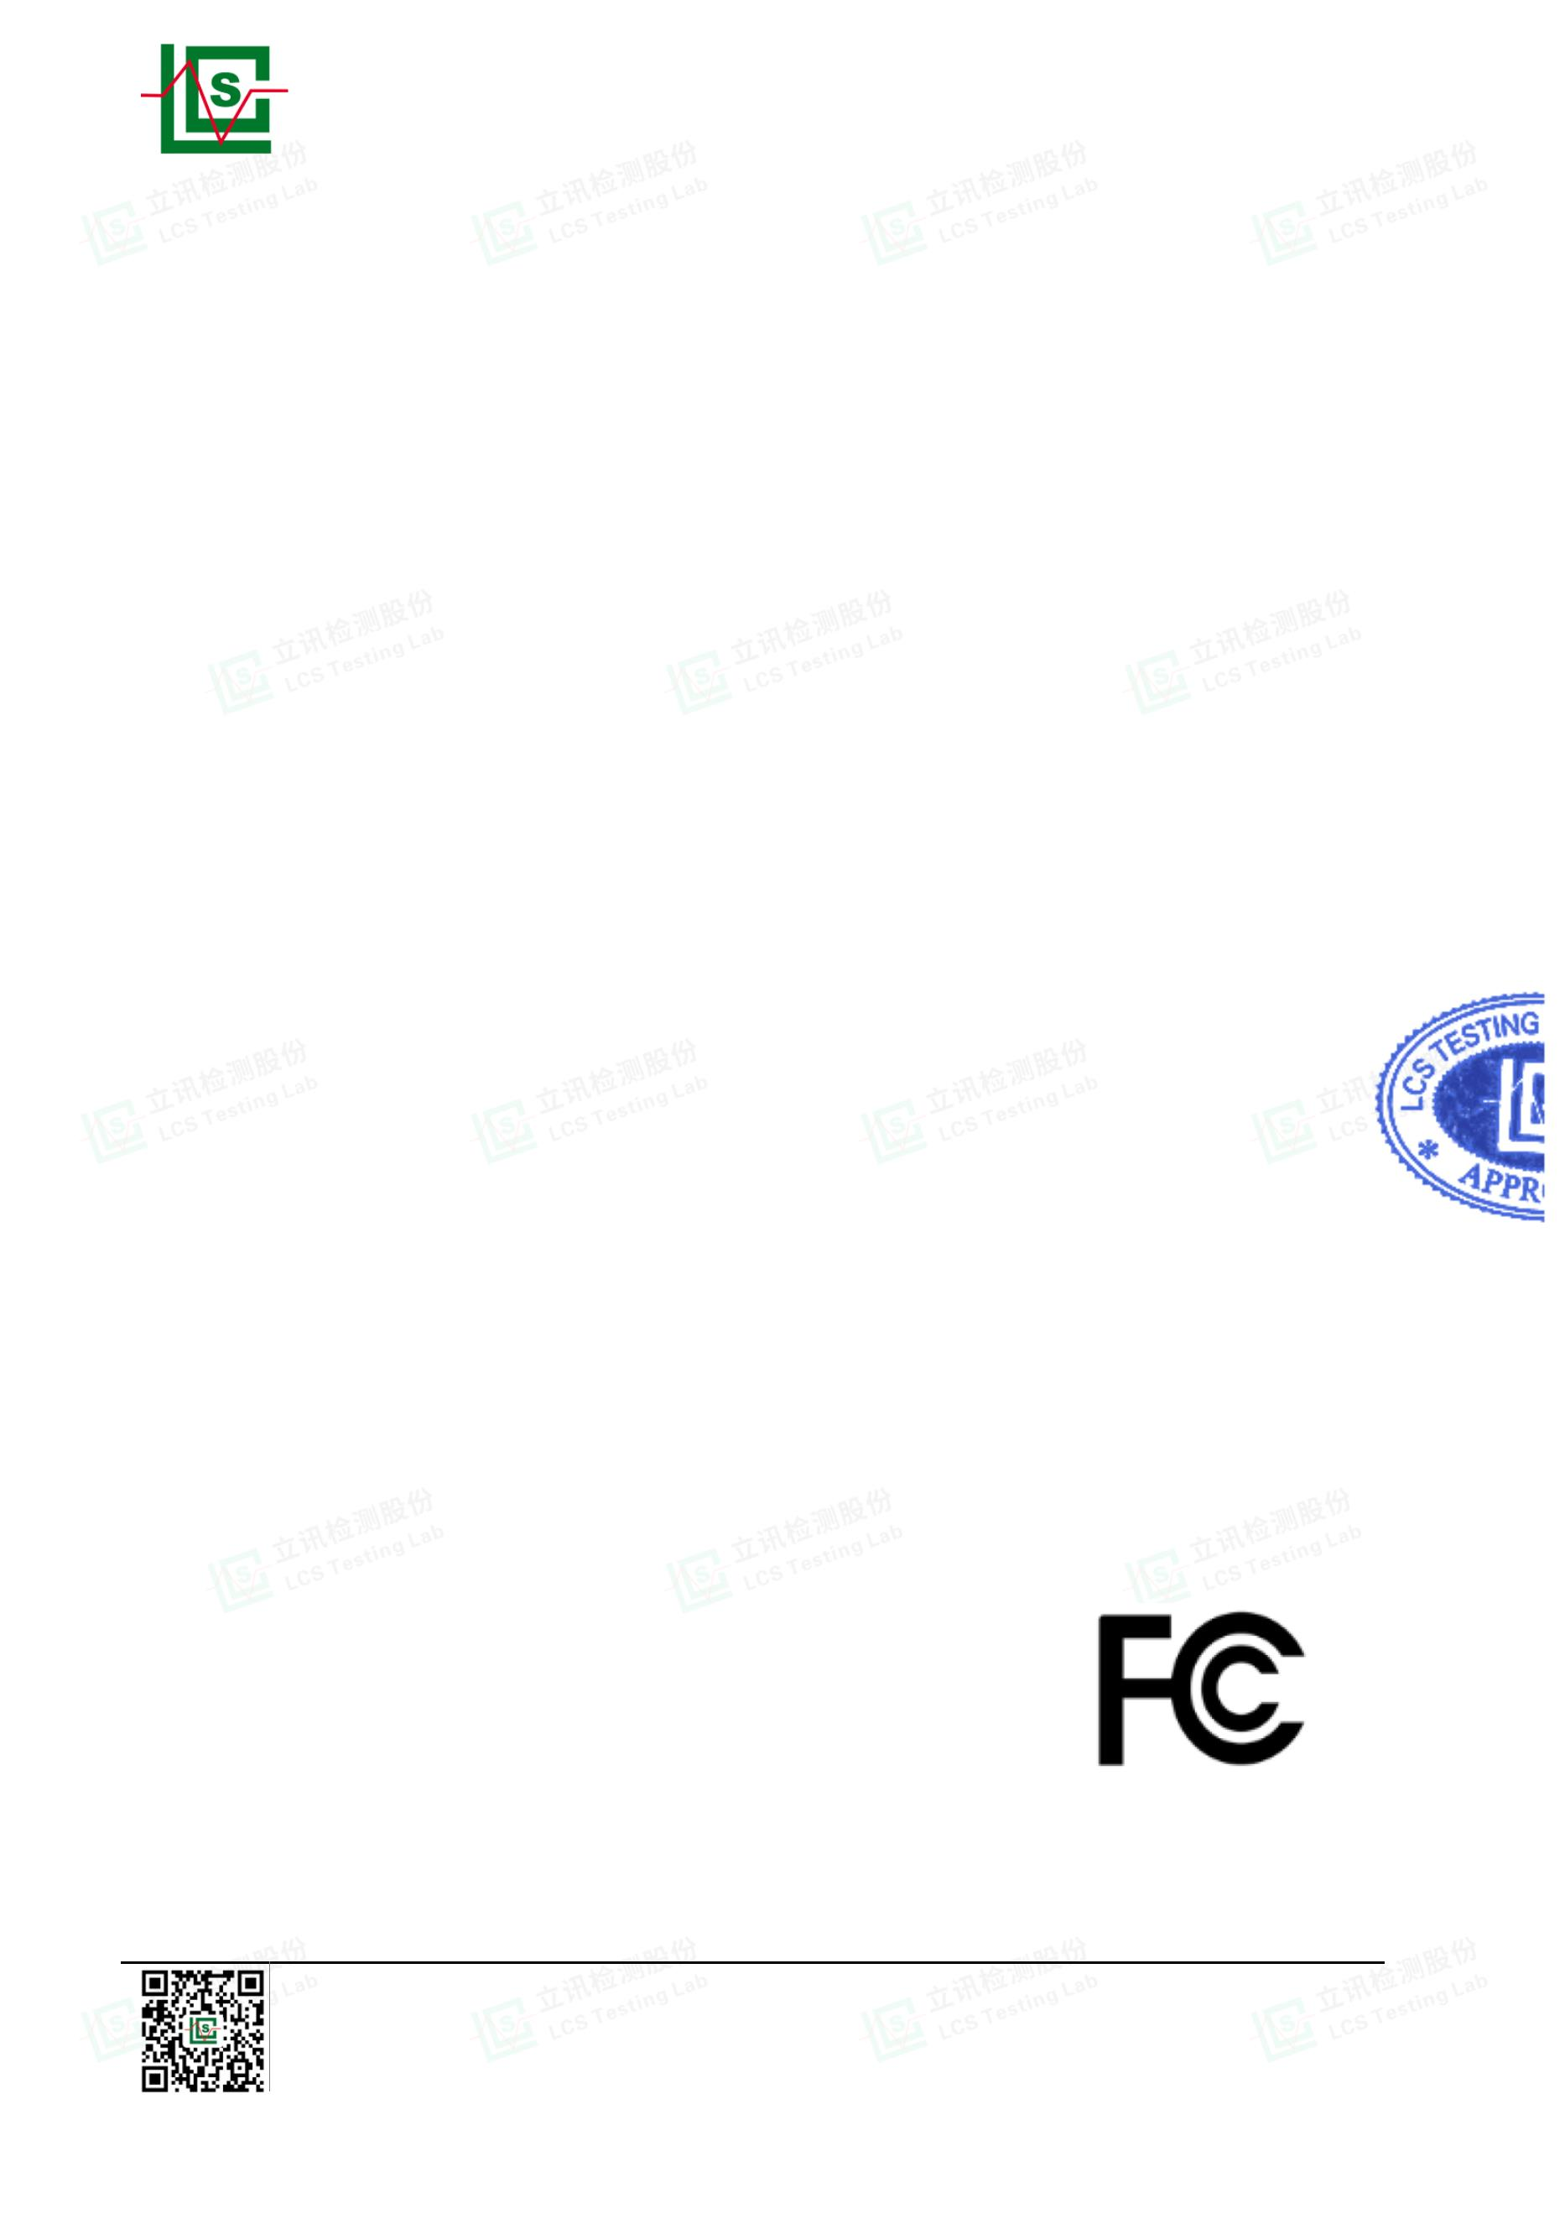

Page 2 of 32
Report No.: LCSA022723066E001
FCC SDoC TEST REPORT
FCC 47 CFR Part 15 Subpart B, Class B(SDoC), ANSI C63.4 -2014
:
Report Reference No. ......... LCSA022723066E001
:
Date Of Issue ......................... March 28, 2024
:
Testing Laboratory Name..... Shenzhen LCS Compliance Testing Laboratory Ltd.
: Room 101, 201, Building A and Room 301, Building C, Juji
Industrial Park, Yabianxueziwei, Shajing Street, Bao’an
District, Shenzhen, Guangdong, China
Address ..................................
: Full application of Harmonised standards ■
Partial application of Harmonised standards □
Other standard testing method □
Testing Location/ Procedure ...
Applicant’s Name.................. : Shenzhen Damin Energy Technology Co., Ltd
B717, Tang Shang Building, No. 35 Xinqiao Section of
Address .................................. : Guangshen Road, Shangxing Community, Xinqiao Street,
Baoan District, Shenzhen City, Guangdong Province, China
Test Specification
:
:
FCC 47 CFR Part 15 Subpart B, Class B(SDoC), ANSI
C63.4 -2014
Test Report Form No. ............. LCSEMC-1.0
Standard.................................
TRF Originator........................ : Shenzhen LCS Compliance Testing Laboratory Ltd.
Master TRF............................. : Dated 2011-03
SHENZHEN LCS COMPLIANCE TESTING LABORATORY LTD. All rights reserved.
This publication may be reproduced in whole or in part for non-commercial purposes as long
as the SHENZHEN LCS COMPLIANCE TESTING LABORATORY LTD. is acknowledged as
copyright owner and source of the material. SHENZHEN LCS COMPLIANCE TESTING
LABORATORY LTD. takes no responsibility for and will not assume liability for damages
resulting from the reader's interpretation of the reproduced material due to its placement and
context.
Test Item Description. .......... : Jump Starter
Test Model ............................ : CAT797
Trade Mark ............................. : N/A
Ratings ................................... : Please Refer to Page 7
Result ................................... : Positive
Compiled by:
Supervised by:
Coco Song/ File administrators
Baron wen/Technique principal
Shenzhen LCS Compliance Testing Laboratory Ltd.
Add: Room 101, 201, Building A and Room 301, Building C, Juji Industrial Park, Yabianxueziwei, Shajing Street,
Bao'an District, Shenzhen, Guangdong, China
Tel: +(86) 0755-82591330 | E-mail: webmaster@lcs-cert.com | Web: www.lcs-cert.com
Scan code to check authenticity
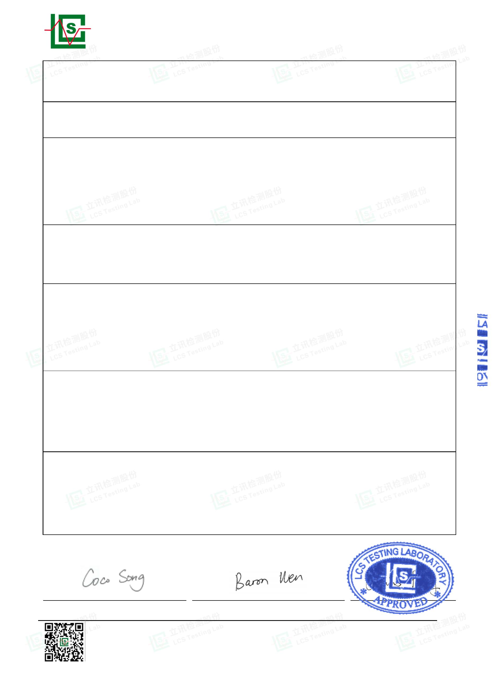

Page 3 of 32
Report No.: LCSA022723066E001
FCC -- TEST REPORT
LCSA022723066E001
March 28, 2024
Date of issue
Test Report No. :
Test Model ........................ : CAT797
EUT.................................... : Jump Starter
Applicant........................... : Shenzhen Damin Energy Technology Co., Ltd
Address.............................. : B717, Tang Shang Building, No. 35 Xinqiao Section of
Guangshen Road, Shangxing Community, Xinqiao Street,
Baoan District, Shenzhen City, Guangdong Province,
China
Telephone.......................... : /
Fax..................................... : /
Manufacturer..................... : Shenzhen Damin Energy Technology Co., Ltd
Address.............................. : B717, Tang Shang Building, No. 35 Xinqiao Section of
Guangshen Road, Shangxing Community, Xinqiao Street,
Baoan District, Shenzhen City, Guangdong Province,
China
Telephone.......................... : /
Fax..................................... : /
Factory.............................. : Shenzhen Damin Energy Technology Co., Ltd
Address.............................. : B717, Tang Shang Building, No. 35 Xinqiao Section of
Guangshen Road, Shangxing Community, Xinqiao Street,
Baoan District, Shenzhen City, Guangdong Province,
China
Telephone.......................... : /
Fax..................................... : /
Test Result according to the standards on page 6: Positive
The test report merely corresponds to the test sample.
It is not permitted to copy extracts of these test result without the written permission of the
test laboratory.
Shenzhen LCS Compliance Testing Laboratory Ltd.
Add: Room 101, 201, Building A and Room 301, Building C, Juji Industrial Park, Yabianxueziwei, Shajing Street,
Bao'an District, Shenzhen, Guangdong, China
Tel: +(86) 0755-82591330 | E-mail: webmaster@lcs-cert.com | Web: www.lcs-cert.com
Scan code to check authenticity
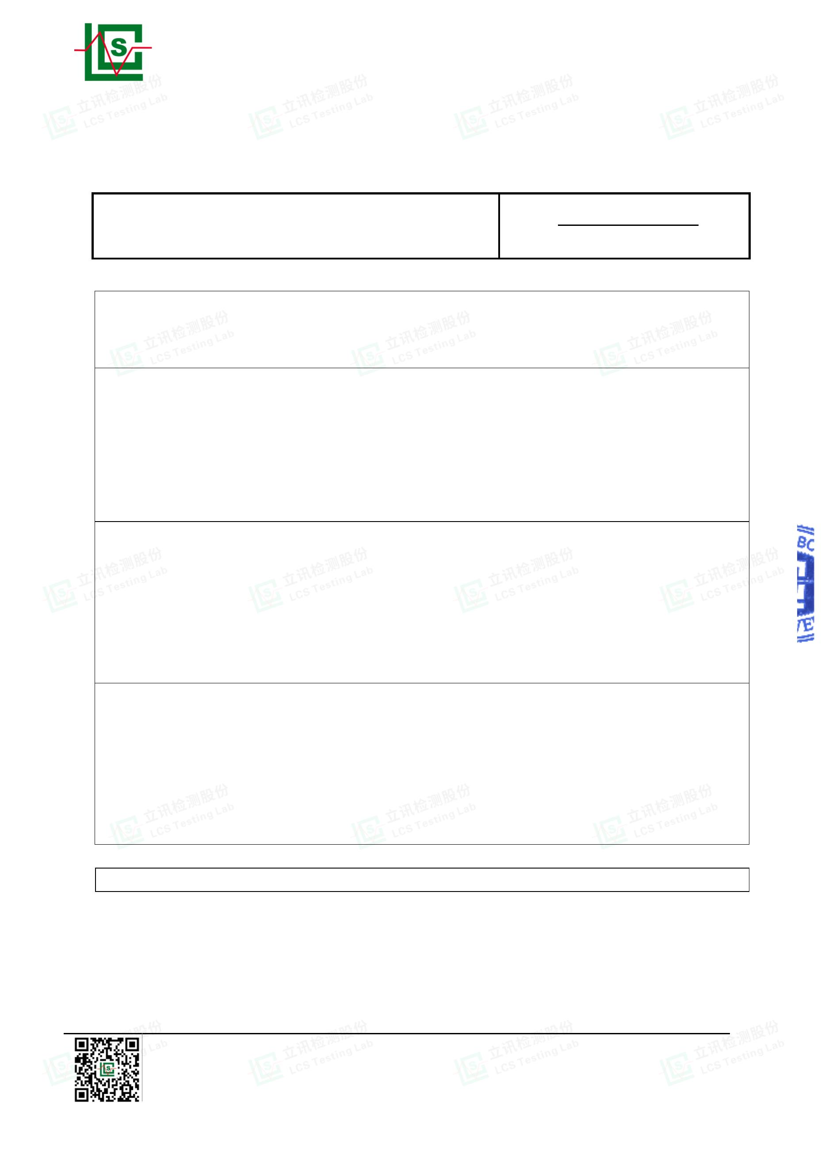

Page 4 of 32
Report No.: LCSA022723066E001
Revision History
Revision
000
Issue Date
April 21, 2023
Revisions Content
Revised By
--
Initial Issue
Declared by
applicant, other
information and
results contained
in this report are
not changed,
001
March 28, 2024
Coco Song
original test report
become invalid.
Shenzhen LCS Compliance Testing Laboratory Ltd.
Add: Room 101, 201, Building A and Room 301, Building C, Juji Industrial Park, Yabianxueziwei, Shajing Street,
Bao'an District, Shenzhen, Guangdong, China
Tel: +(86) 0755-82591330 | E-mail: webmaster@lcs-cert.com | Web: www.lcs-cert.com
Scan code to check authenticity
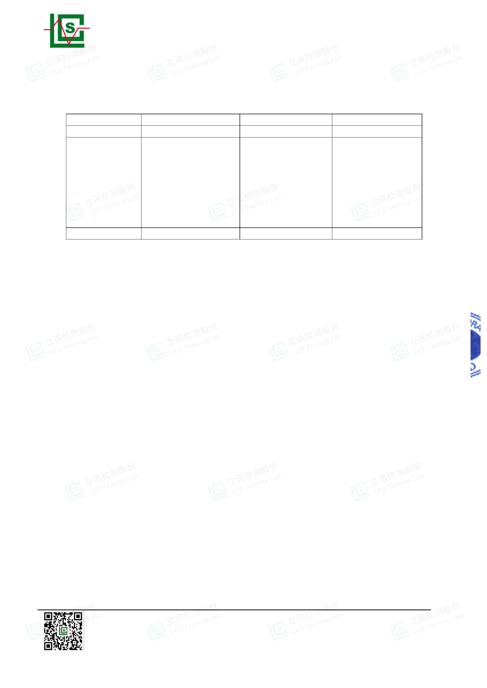

Page 5 of 32
Report No.: LCSA022723066E001
TABLE OF CONTENTS
Test Report Description
Page
1.1. Description of Standards and Results.................................................................................. 6
2.1. Description of Device (EUT)........................................................................................................ 7
2.2. Support equipment List................................................................................................................ 7
2.3. Description of Test Facility .......................................................................................................... 7
2.4. Statement of the Measurement Uncertainty............................................................................. 8
2.5. Measurement Uncertainty............................................................................................................ 8
3.1. POWER LINE CONDUCTED EMISSION MEASUREMENT................................................. 9
3.2. Radiated emission Measurement............................................................................................. 13
5. EXTERNAL AND INTERNAL PHOTOS OF THE EUT................................................... 28
Shenzhen LCS Compliance Testing Laboratory Ltd.
Add: Room 101, 201, Building A and Room 301, Building C, Juji Industrial Park, Yabianxueziwei, Shajing Street,
Bao'an District, Shenzhen, Guangdong, China
Tel: +(86) 0755-82591330 | E-mail: webmaster@lcs-cert.com | Web: www.lcs-cert.com
Scan code to check authenticity
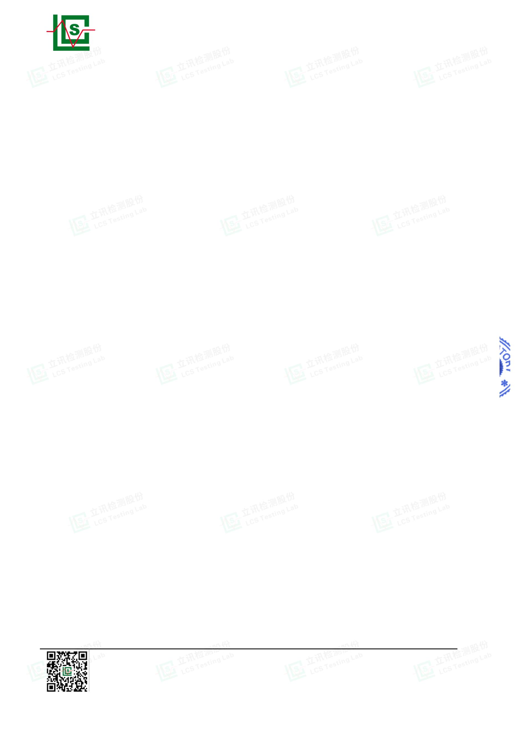

Page 6 of 32
Report No.: LCSA022723066E001
1. SUMMARY OF STANDARDS AND RESULTS
1.1. Description of Standards and Results
The EUT have been tested according to the applicable standards as referenced below.
EMISSION
Description of Test Item
Standard
Limits Results
Conducted disturbance FCC 47 CFR Part 15 Subpart B, Class
---
---
PASS
PASS
at mains terminals
B(SDoC), ANSI C63.4 -2014
FCC 47 CFR Part 15 Subpart B, Class
B(SDoC), ANSI C63.4 -2014
Radiated disturbance
N/A is an abbreviation for Not Applicable.
Test mode:
Mode 1
Mode 2
Charging
Full Load
Record
Record
***Note: All test modes were tested, but we only recorded the worst case in this report.
Shenzhen LCS Compliance Testing Laboratory Ltd.
Add: Room 101, 201, Building A and Room 301, Building C, Juji Industrial Park, Yabianxueziwei, Shajing Street,
Bao'an District, Shenzhen, Guangdong, China
Tel: +(86) 0755-82591330 | E-mail: webmaster@lcs-cert.com | Web: www.lcs-cert.com
Scan code to check authenticity
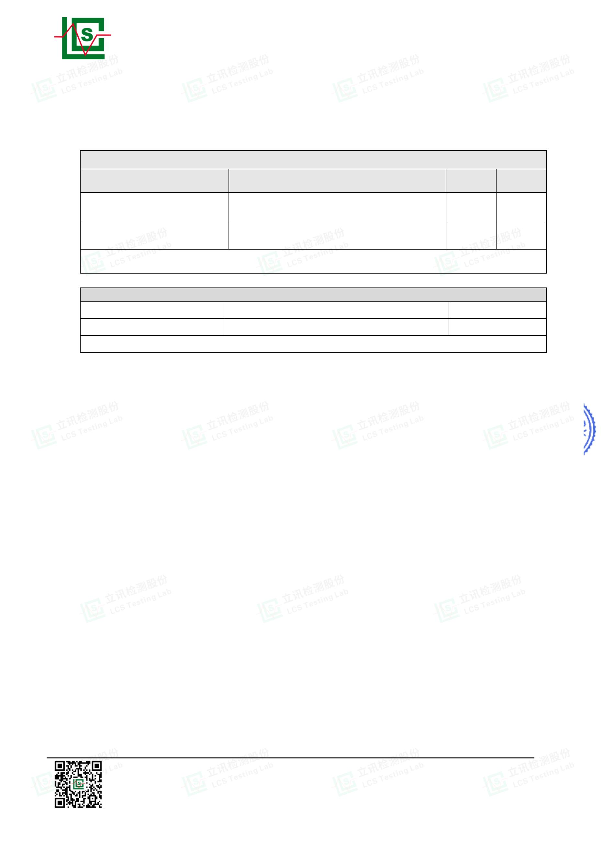

Page 7 of 32
Report No.: LCSA022723066E001
2. GENERAL INFORMATION
2.1. Description of Device (EUT)
EUT
: Jump Starter
Trade Mark
: N/A
Test Model
: CAT797
Power Supply
: Rating Capacity: 64000mAH
Starting voltage :12/24V
Starting current: 3000A (12V) 一 1500A( 24V)
Input voltage: 19V-(3A)
USB output: QC 18W
Type-c: PD45W
DC output: 12V-16.5V Max 10A
Vehicle charging source port: 12-16.5V Max 10A
Highest internal freq. : Fx≤108MHz
Highest internal frequency (Fx)
Highest measured frequency
Fx ≤1.705 MHz
1.705 MHz < Fx ≤ 108 MHz
108 MHz < Fx ≤ 500 MHz
500 MHz < Fx ≤ 1000 MHz
Fx > 1 GHz
30 MHz
1 GHz
2 GHz
5 GHz
5 × Fx up to a maximum of 40 GH
2.2. Support equipment List
Name
Adapter
Manufacturers
--
M/N
--
S/N
--
2.3. Description of Test Facility
Site Description
EMC Lab.
: NVLAP Accreditation Code is 600167-0.
FCC Designation Number is CN5024.
CAB identifier is CN0071.
CNAS Registration Number is L4595.
Shenzhen LCS Compliance Testing Laboratory Ltd.
Add: Room 101, 201, Building A and Room 301, Building C, Juji Industrial Park, Yabianxueziwei, Shajing Street,
Bao'an District, Shenzhen, Guangdong, China
Tel: +(86) 0755-82591330 | E-mail: webmaster@lcs-cert.com | Web: www.lcs-cert.com
Scan code to check authenticity
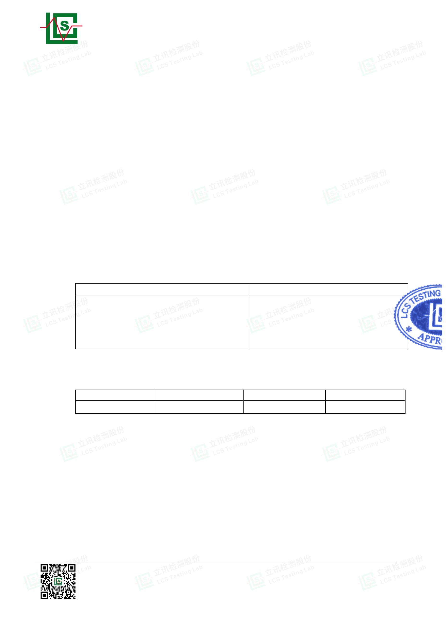

Page 8 of 32
Report No.: LCSA022723066E001
2.4. Statement of the Measurement Uncertainty
The data and results referenced in this document are true and accurate. The
reader is cautioned that there may be errors within the calibration limits of the
equipment and facilities. The measurement uncertainty was calculated for all
measurements listed in this test report acc. To CISPR 16 – 4 “Specification for
radio disturbance and immunity measuring apparatus and methods – Part 4:
Uncertainty in EMC Measurements” and is documented in the LCS quality
system acc. To DIN EN ISO/IEC 17025. Furthermore, component and process
variability of devices similar to that tested may result in additional deviation. The
manufacturer has the sole responsibility of continued compliance of the device.
2.5. Measurement Uncertainty
Expanded
Uncertainty
(Ulab)
Expanded
Uncertainty
(Ucispr)
Test
Parameters
Level accuracy
(9kHz to 150kHz)
(150kHz to 30MHz)
Conducted
Emission
2.63 dB
2.35 dB
3.8 dB
3.4 dB
Level accuracy
(9kHz to 30MHz)
Radiated Emission
Radiated Emission
Radiated Emission
3.68 dB
3.48 dB
3.90 dB
N/A
Level accuracy
(30MHz to 1000MHz)
5.3 dB
5.2 dB
Level accuracy
(above 1000MHz)
（1）Where relevant, the following measurement uncertainty levels have been estimated
for tests performed on the apparatus.
（2）The reported expanded uncertainty of measurement is stated as the standard
uncertainty of measurement multiplied by the coverage factor of k=2, which for a normal
distribution corresponds to a coverage probability of approximately 95%.
Shenzhen LCS Compliance Testing Laboratory Ltd.
Add: Room 101, 201, Building A and Room 301, Building C, Juji Industrial Park, Yabianxueziwei, Shajing Street,
Bao'an District, Shenzhen, Guangdong, China
Tel: +(86) 0755-82591330 | E-mail: webmaster@lcs-cert.com | Web: www.lcs-cert.com
Scan code to check authenticity
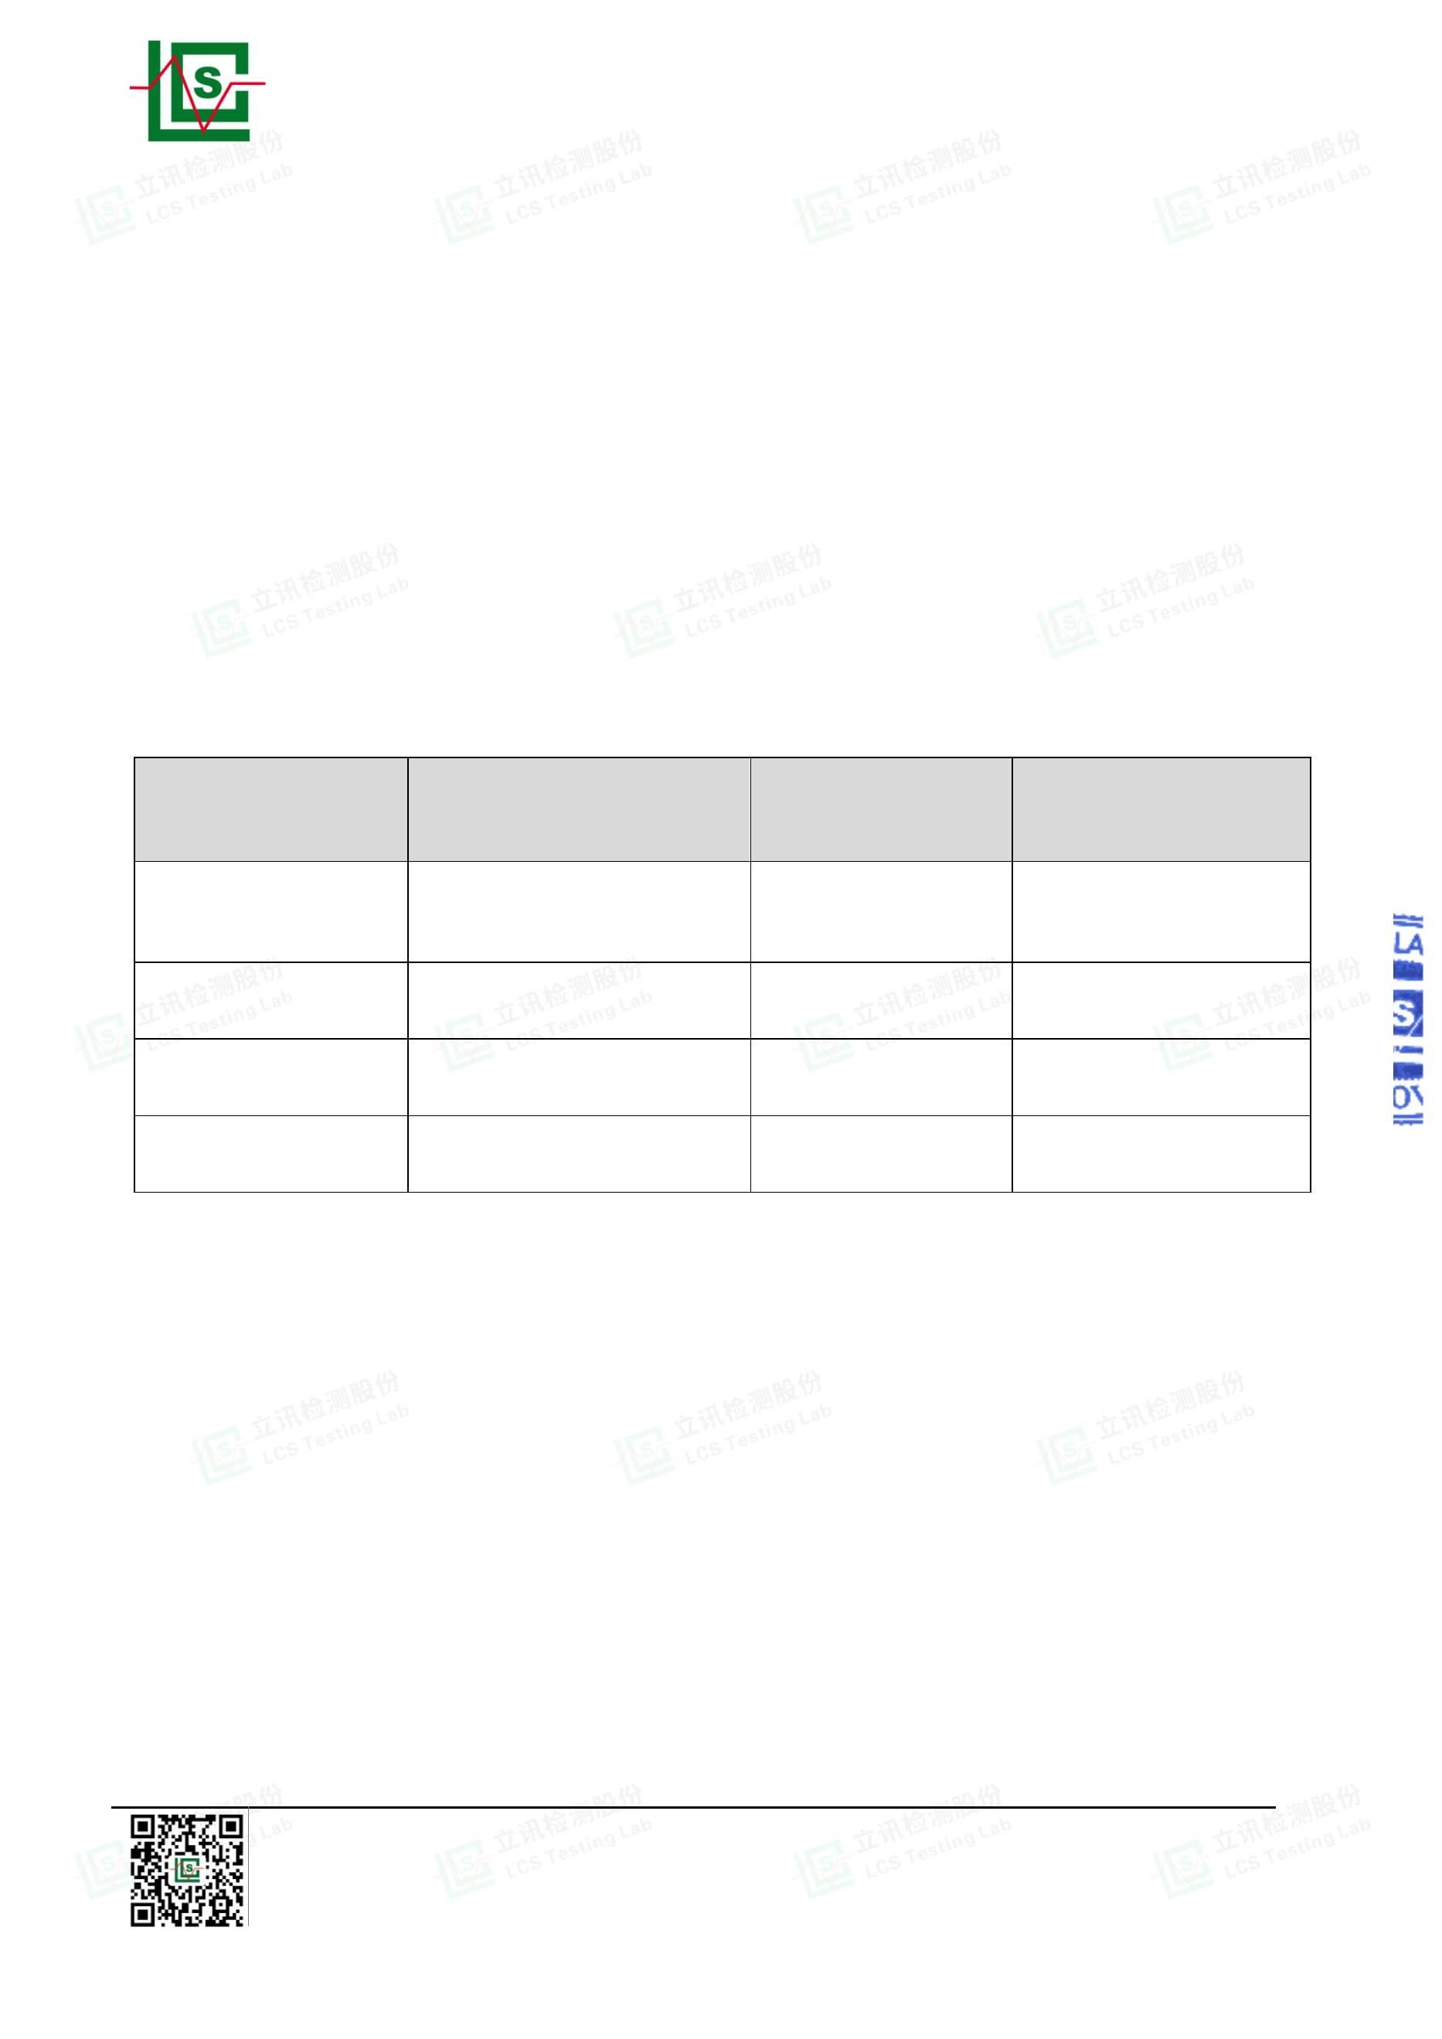

Page 9 of 32
Report No.: LCSA022723066E001
3. TEST RESULTS
3.1. POWER LINE CONDUCTED EMISSION MEASUREMENT
3.1.1. Test Equipment
The following test equipments are used during the power line conducted measurement:
Item
Equipment
EMI Test Software
EMI Test Receiver
Artificial Mains
Pulse Limiter
Manufacturer
Farad
Model No.
EZ
Serial No.
/
Cal Date
N/A
Due Date
N/A
1
2
3
4
R&S
ESR3
102312
101288
102750-NB
2023-02-25 2024-02-24
2022-06-16 2023-06-15
2022-08-17 2023-08-16
R&S
ENV216
ESH3-Z2
R&S
3.1.2.Block Diagram of Test Setup
3.1.3.Test Standard
Power Line Conducted Emission Limits
Frequency
Limit (dBV)
(MHz)
Quasi-peak Level
Average Level
0.15
0.50
5.00
~
~
~
0.50
5.00
30.00
66.0 ~ 56.0 *
56.0
56.0 ~ 46.0 *
46.0
60.0
50.0
NOTE1-The lower limit shall apply at the transition frequencies.
NOTE2-The limit decreases linearly with the logarithm of the
frequency in the range 0.15MHz to 0.50MHz.
3.1.4.EUT Configuration on Test
The following equipments are installed on Power Line Conducted Emission
Measurement to meet the commission requirement and operating regulations in
a manner, which tends to maximize its emission characteristics in a normal
application.
Shenzhen LCS Compliance Testing Laboratory Ltd.
Add: Room 101, 201, Building A and Room 301, Building C, Juji Industrial Park, Yabianxueziwei, Shajing Street,
Bao'an District, Shenzhen, Guangdong, China
Tel: +(86) 0755-82591330 | E-mail: webmaster@lcs-cert.com | Web: www.lcs-cert.com
Scan code to check authenticity
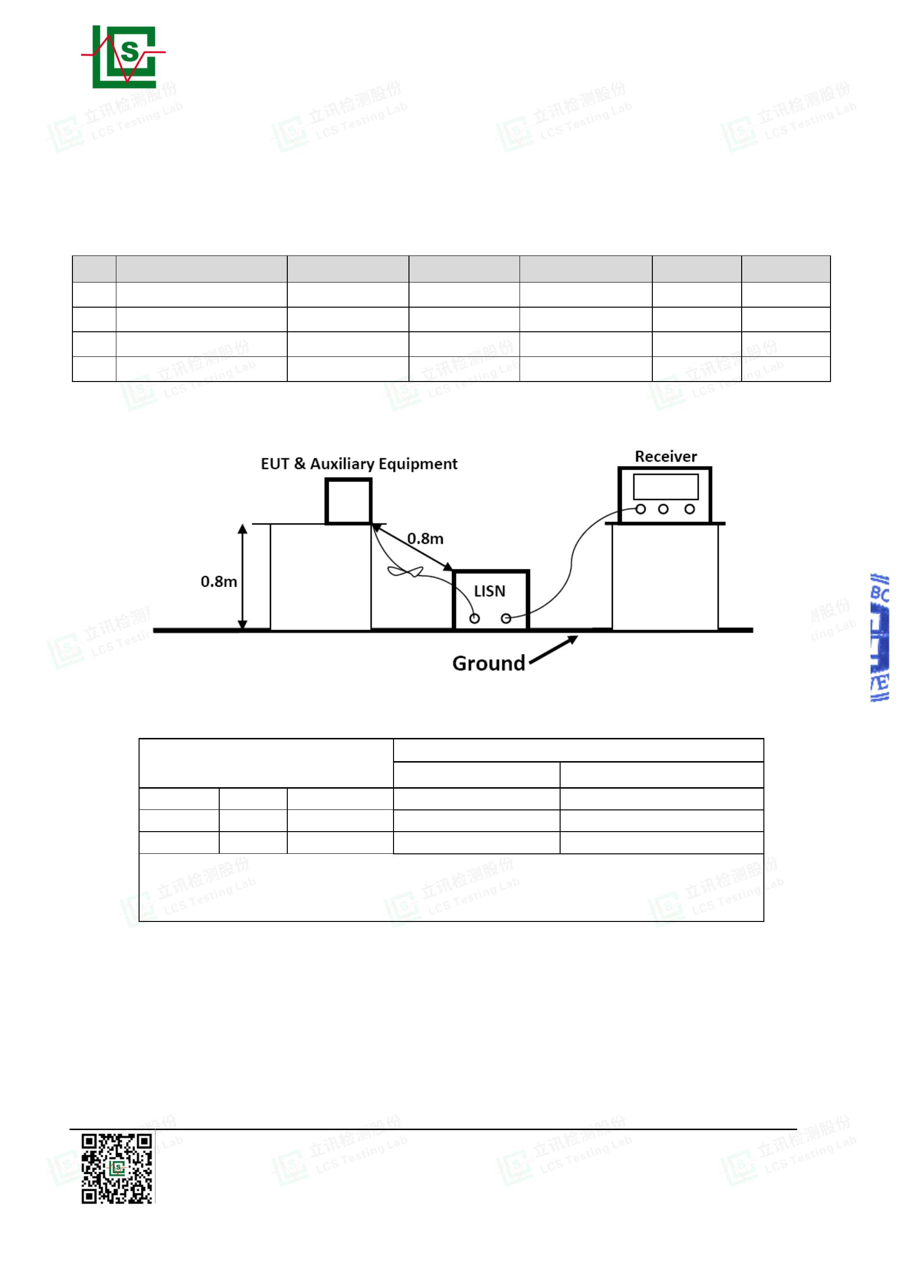

Page 10 of 32
Report No.: LCSA022723066E001
3.1.5.Operating Condition of EUT
3.1.5.1.Setup the EUT as shown on Section 3.1.2
3.1.5.2.Turn on the power of all equipments.
3.1.5.3.Let the EUT work in measuring Mode 1 and measure it.
3.1.6.Test Procedure
The EUT system is connected to the power mains through a line impedance
stabilization network (L.I.S.N.). This provides 50ohm coupling impedance for the
EUT system. Please refer the block diagram of the test setup and photographs.
Both sides of AC line are checked to find out the maximum conducted emission.
In order to find the maximum emission levels, the relative positions of
equipment and all of the interface cables shall be changed according to
FCC/ANSI C63.4-2014 on Conducted Emission Measurement.
The bandwidth of the test receiver is set at 9kHz.
The frequency range from 150kHz to 30MHz is investigated
3.1.7.Test Results
PASS.
The test result please refer to the next page.
Shenzhen LCS Compliance Testing Laboratory Ltd.
Add: Room 101, 201, Building A and Room 301, Building C, Juji Industrial Park, Yabianxueziwei, Shajing Street,
Bao'an District, Shenzhen, Guangdong, China
Tel: +(86) 0755-82591330 | E-mail: webmaster@lcs-cert.com | Web: www.lcs-cert.com
Scan code to check authenticity
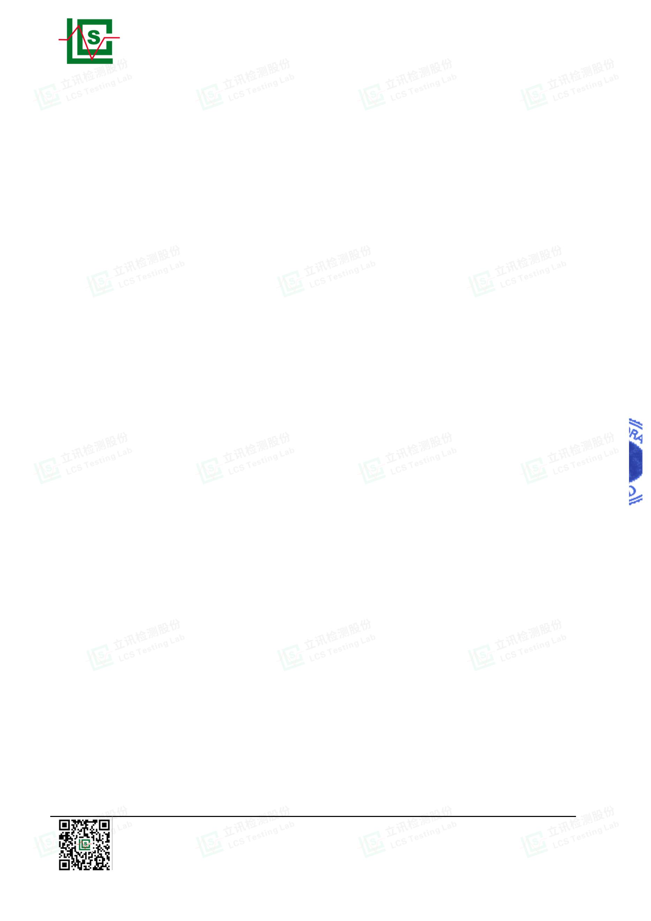

Page 11 of 32
Report No.: LCSA022723066E001
Test Model
Environmental Conditions 24.3℃, 53.5% RH
Pol Line
CAT797
Test Mode
Test Engineer
Test Voltage
Mode 1
Xf Peng
AC 120V/60Hz
Note: Margin= Reading level + Correct factor – Limit
Correct Factor= Lisn Factor+Cable Factor+Limiter Factor
Shenzhen LCS Compliance Testing Laboratory Ltd.
Add: Room 101, 201, Building A and Room 301, Building C, Juji Industrial Park, Yabianxueziwei, Shajing Street,
Bao'an District, Shenzhen, Guangdong, China
Tel: +(86) 0755-82591330 | E-mail: webmaster@lcs-cert.com | Web: www.lcs-cert.com
Scan code to check authenticity
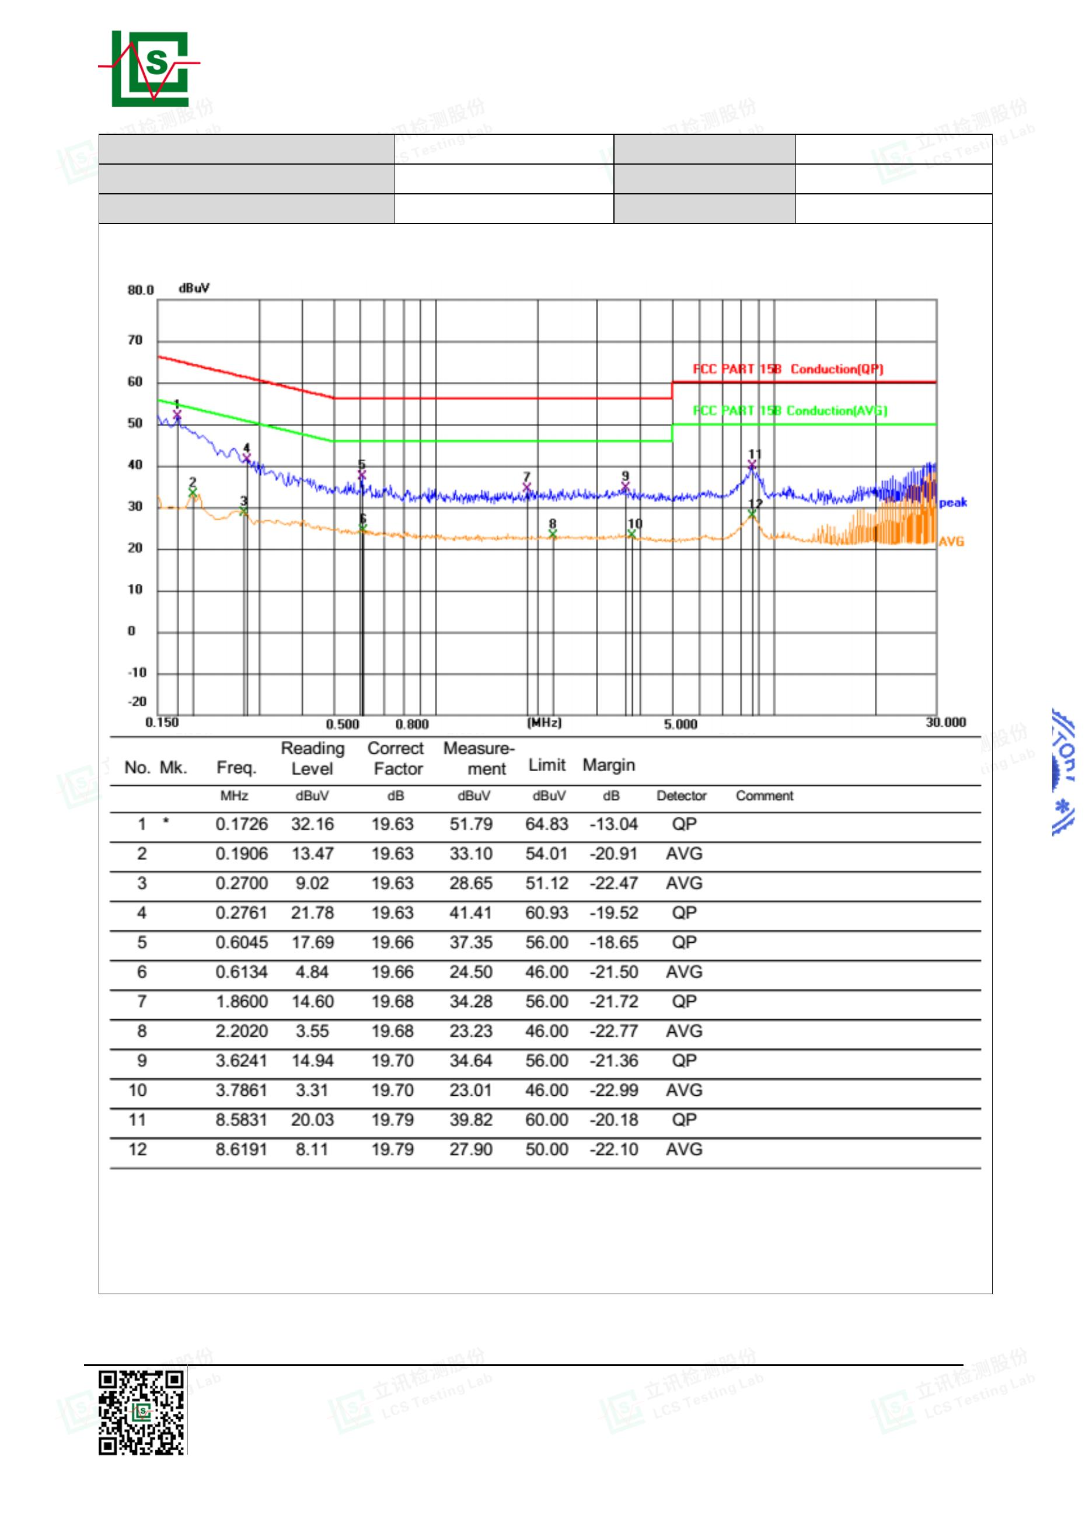

Page 12 of 32
Report No.: LCSA022723066E001
Test Model
Environmental Conditions 24.3℃, 53.5% RH
Pol Neutral
CAT797
Test Mode
Test Engineer
Test Voltage
Mode 1
Xf Peng
AC 120V/60Hz
Note: Margin= Reading level + Correct factor – Limit
Correct Factor= Lisn Factor+Cable Factor+Limiter Factor
Note: Pre-Scan all mode, Thus record worse case mode result in this report.
Shenzhen LCS Compliance Testing Laboratory Ltd.
Add: Room 101, 201, Building A and Room 301, Building C, Juji Industrial Park, Yabianxueziwei, Shajing Street,
Bao'an District, Shenzhen, Guangdong, China
Tel: +(86) 0755-82591330 | E-mail: webmaster@lcs-cert.com | Web: www.lcs-cert.com
Scan code to check authenticity
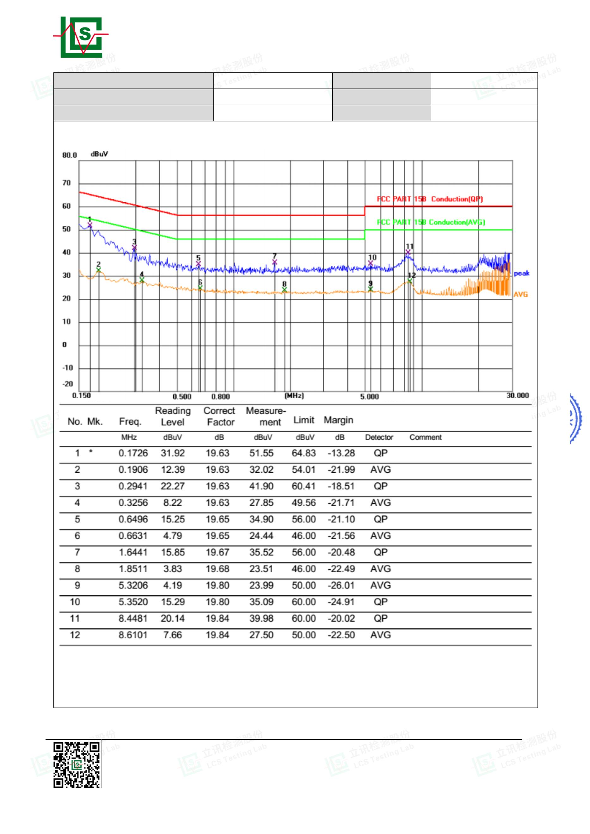

Page 13 of 32
3.2. Radiated emission Measurement
3.2.1. Test Equipment
Report No.: LCSA022723066E001
The following test equipments are used during the radiated emission measurement:
Item
Equipment
EMI Test Software
By-log Antenna
Manufacturer
AUDIX
Model No.
E3
Serial No.
/
Cal Date
N/A
Due Date
N/A
1
2
3
4
5
SCHWARZBECK
VULB9163
9163-470
9120D-1925
102311
2021-09-12
2021-09-05
2022-08-17
2022-06-16
2024-09-11
2024-09-04
2023-08-16
2023-06-15
Horn Antenna
SCHWARZBECK BBHA 9120D
EMI Test Receiver
Broadband Preamplifier
R&S
/
ESR3
BP-01M18G
P190501
3.2.2. Block Diagram of Test Setup
Shenzhen LCS Compliance Testing Laboratory Ltd.
Add: Room 101, 201, Building A and Room 301, Building C, Juji Industrial Park, Yabianxueziwei, Shajing Street,
Bao'an District, Shenzhen, Guangdong, China
Tel: +(86) 0755-82591330 | E-mail: webmaster@lcs-cert.com | Web: www.lcs-cert.com
Scan code to check authenticity
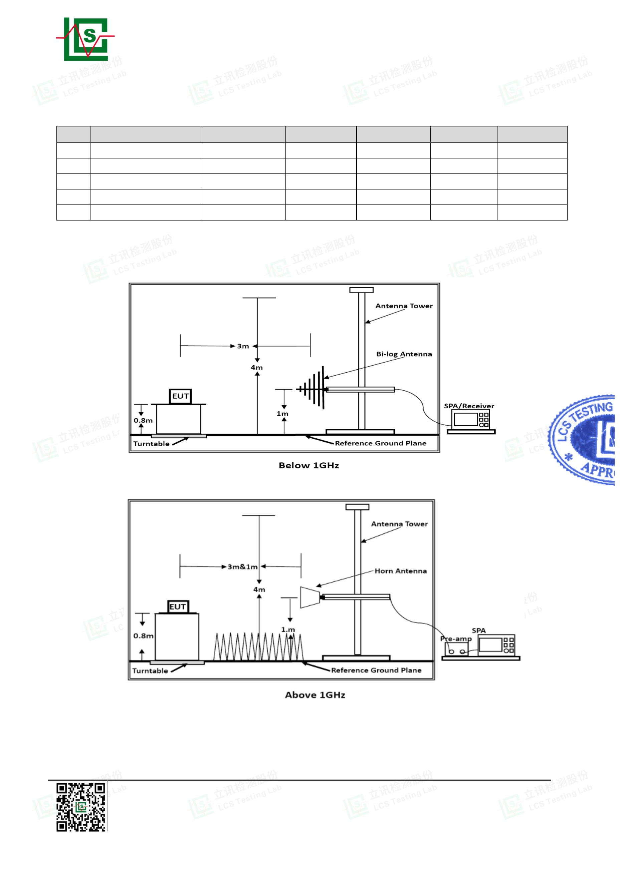

Page 14 of 32
Report No.: LCSA022723066E001
3.2.3. Radiated Emission Limit
Limits for Radiated Disturbance Below 1GHz
FREQUENCY
MHz
30 ~ 88
88 ~ 216
216 ~ 960
960 ~ 1000
DISTANCE
Meters
FIELD STRENGTHS LIMIT

V/m
dB( V)/m
40

3
3
3
3
100
150
200
500
43.5
46
54
Remark：(1) Emission level (dB)V = 20 log Emission level V/m
(2) The smaller limit shall apply at the cross point between two
frequency bands.
(3) Distance is the distance in meters between the measuring
instrument, antenna and the closest point of any part of the
device or system.
Limits for Radiated Emission Above 1GHz
Frequency
(MHz)
Above 1000
Distance
(Meters)
3
Peak Limit
(dBμV/m)
74
Average Limit
(dBμV/m)
54
***Note: The lower limit applies at the transition frequency.
3.2.4. EUT Configuration on Measurement
The following equipment are installed on Radiated Emission Measurement to
meet the commission requirements and operating regulations in a manner which
tends to maximize its emission characteristics in normal application.
3.2.5. Operating Condition of EUT
3.2.5.1.Setup the EUT as shown in Section 3.2.2.
3.2.5.2.Let the EUT work in test Mode 1 and measure it.
3.2.6. Test Procedure
EUT and its simulators are placed on a turntable, which is 0.8 meter high above
ground. The turntable can rotate 360 degrees to determine the position of the
maximum emission level. EUT is set 3.0 meters away from the receiving
antenna, which is mounted on a antenna tower. The antenna can be moved up
and down between 1.0 meter and 4 meters to find out the maximum emission
level. Broadband antenna (calibrated by-log antenna) is used as receiving
antenna. Both horizontal and vertical polarization of the antenna is set on
measurement. In order to find the maximum emission levels, all of the interface
cables must be manipulated according to ANSI C63.4-2014 on radiated
emission measurement.
Shenzhen LCS Compliance Testing Laboratory Ltd.
Add: Room 101, 201, Building A and Room 301, Building C, Juji Industrial Park, Yabianxueziwei, Shajing Street,
Bao'an District, Shenzhen, Guangdong, China
Tel: +(86) 0755-82591330 | E-mail: webmaster@lcs-cert.com | Web: www.lcs-cert.com
Scan code to check authenticity
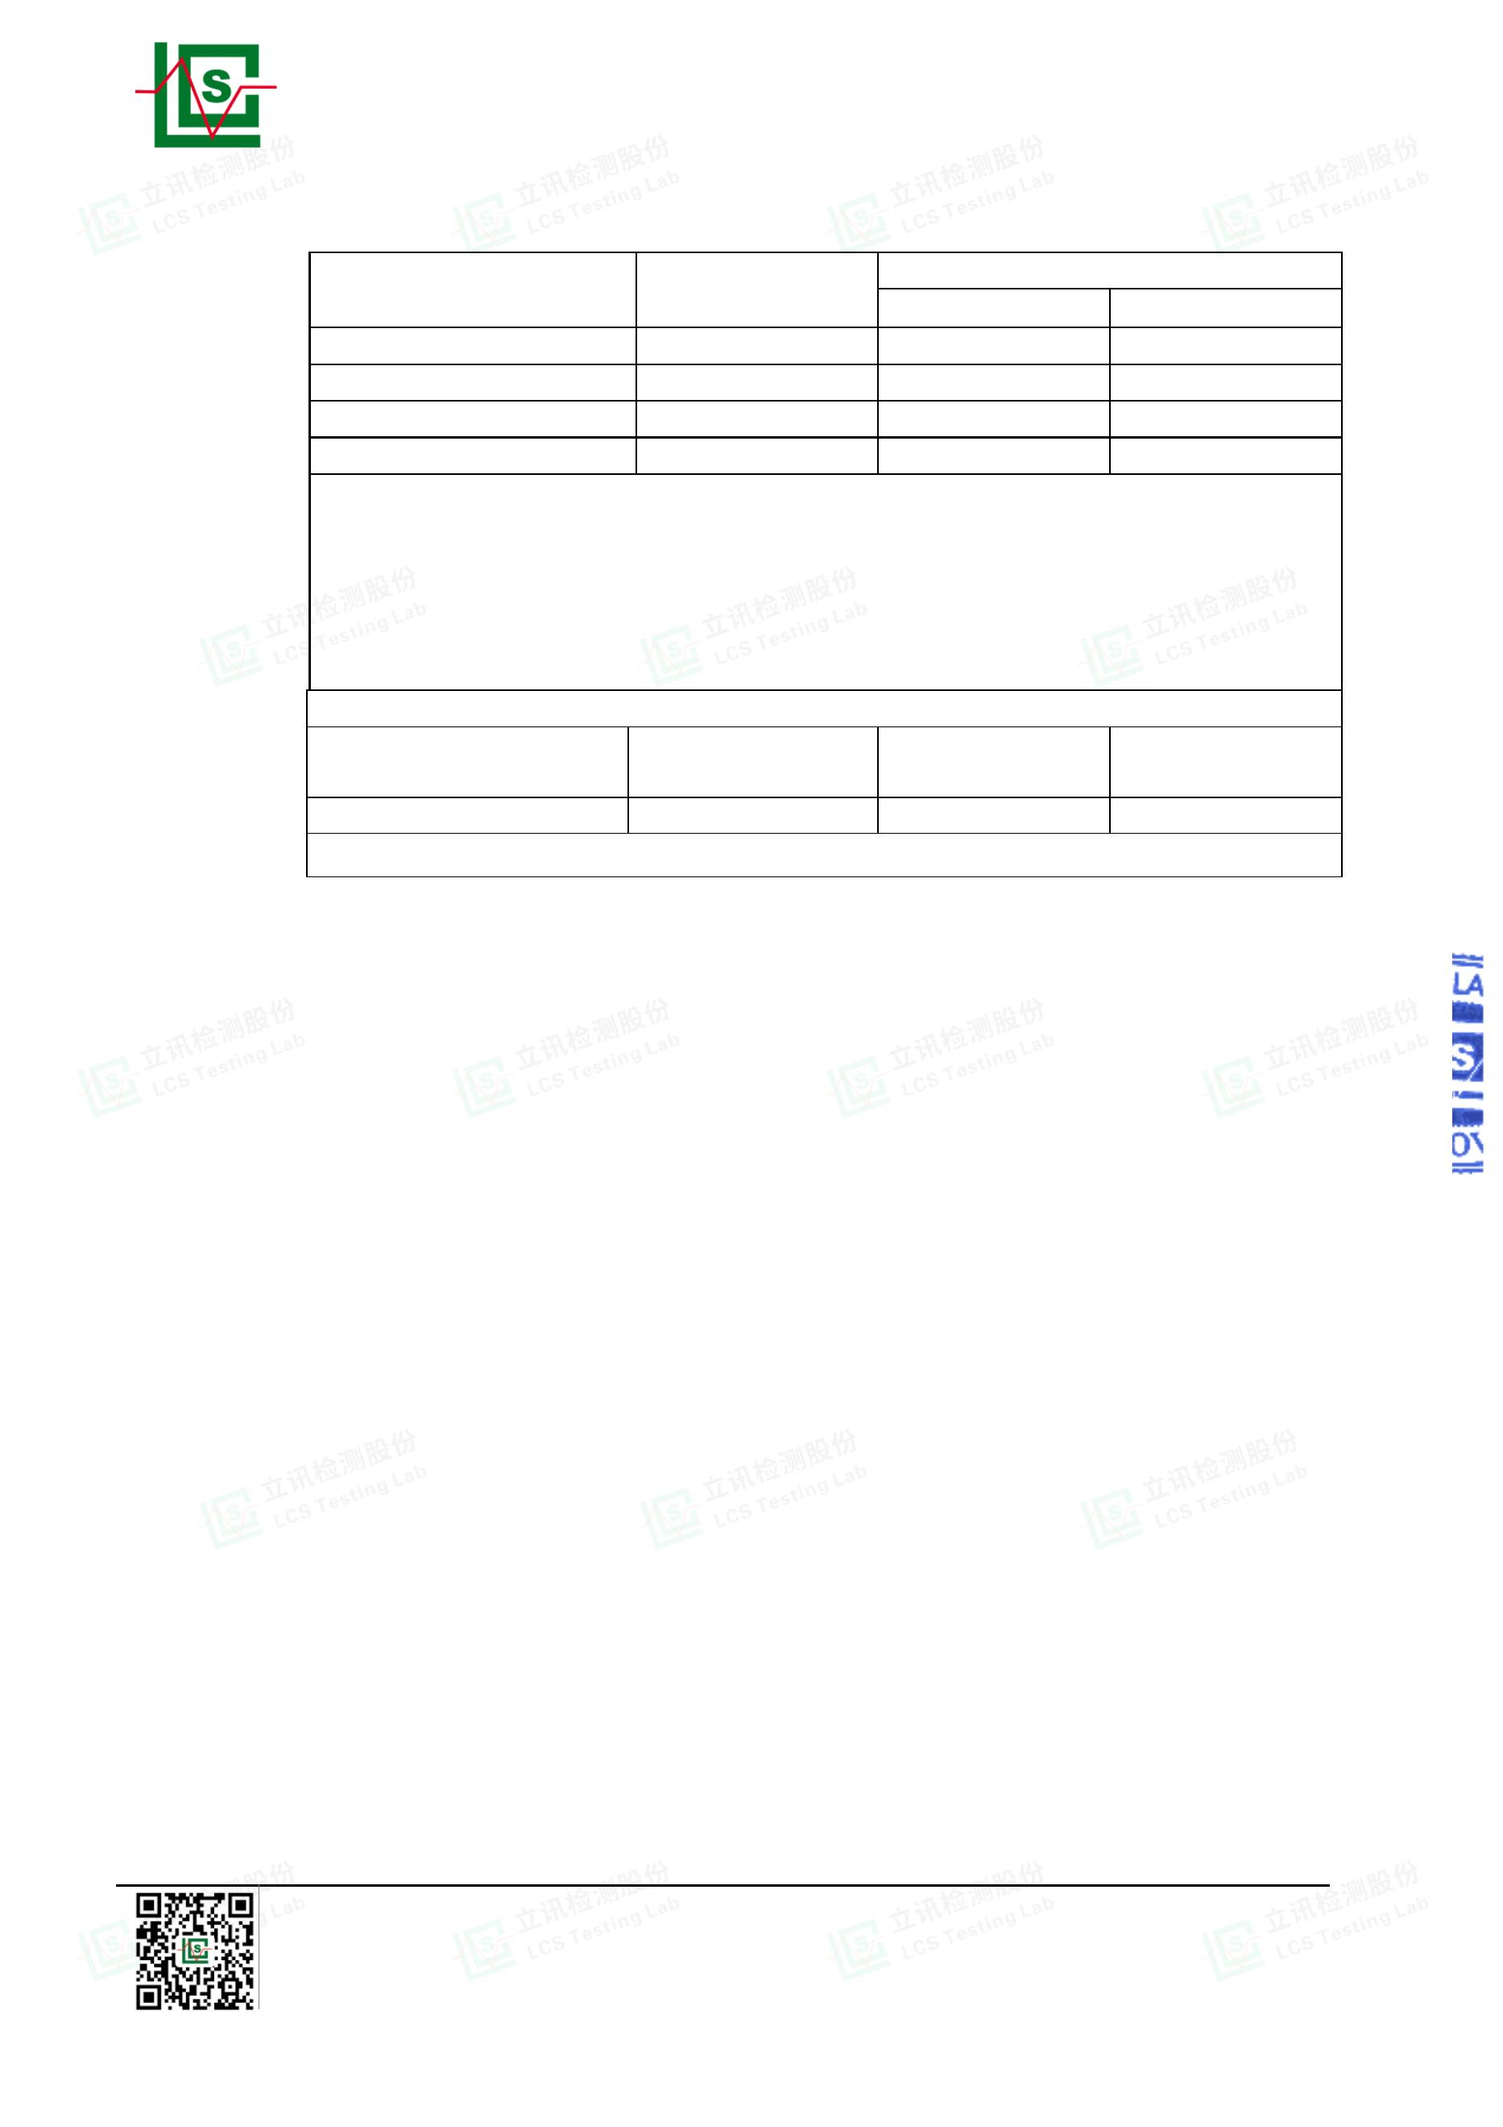

Page 15 of 32
Report No.: LCSA022723066E001
3.2.7. Measuring Instruments and Setting
Please refer to equipment list in this report. The following table is the setting of spectrum
analyzer and receiver
Receiver Parameter
Attenuation
Setting
Auto
Start ~ Stop Frequency
9kHz~150kHz / RB/VB 200Hz/1KHz for QP/AVG
Start ~ Stop Frequency
Start ~ Stop Frequency
150kHz~30MHz / RB/VB 9kHz/30KHz for QP/AVG
30MHz~1000MHz / RB/VB 120kHz/1MHz for QP
Spectrum Parameter
Setting
Attenuation
Auto
Start Frequency
Stop Frequency
1000 MHz
10th carrier harmonic
RB / VB (Emission in restricted band)
RB / VB (Emission in non-restricted band)
1MHz / 1MHz for Peak, 1 MHz / 1/B kHz for Average
1MHz / 1MHz for Peak, 1 MHz / 1/B kHz for Average
The frequency range from 30MHz to 1000MHz and above 1000MHz is checked.
3.2.8. Radiated Emission Noise Measurement Result
PASS.
The scanning waveforms please refer to the next page.
Shenzhen LCS Compliance Testing Laboratory Ltd.
Add: Room 101, 201, Building A and Room 301, Building C, Juji Industrial Park, Yabianxueziwei, Shajing Street,
Bao'an District, Shenzhen, Guangdong, China
Tel: +(86) 0755-82591330 | E-mail: webmaster@lcs-cert.com | Web: www.lcs-cert.com
Scan code to check authenticity
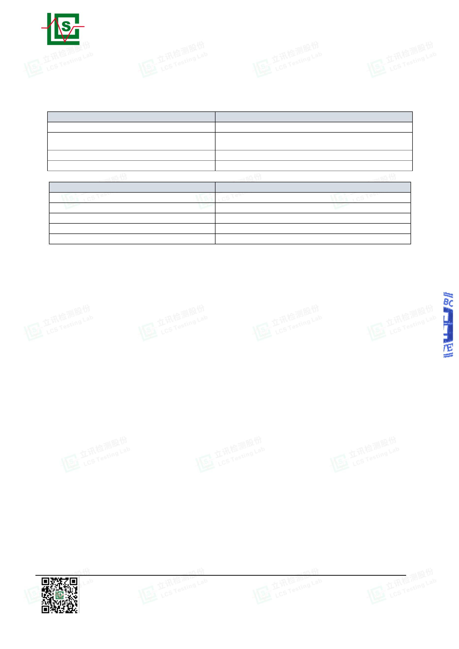

Page 16 of 32
Report No.: LCSA022723066E001
Test Model
CAT797
Test Mode
Mode 1
Environmental Conditions 22.3℃, 53% RH
Detector Function Quasi-peak
Pol
Vertical
Xf Peng
Distance
Test Voltage
3m
Test Engineer
AC 120V/60Hz
Shenzhen LCS Compliance Testing Laboratory Ltd.
Add: Room 101, 201, Building A and Room 301, Building C, Juji Industrial Park, Yabianxueziwei, Shajing Street,
Bao'an District, Shenzhen, Guangdong, China
Tel: +(86) 0755-82591330 | E-mail: webmaster@lcs-cert.com | Web: www.lcs-cert.com
Scan code to check authenticity
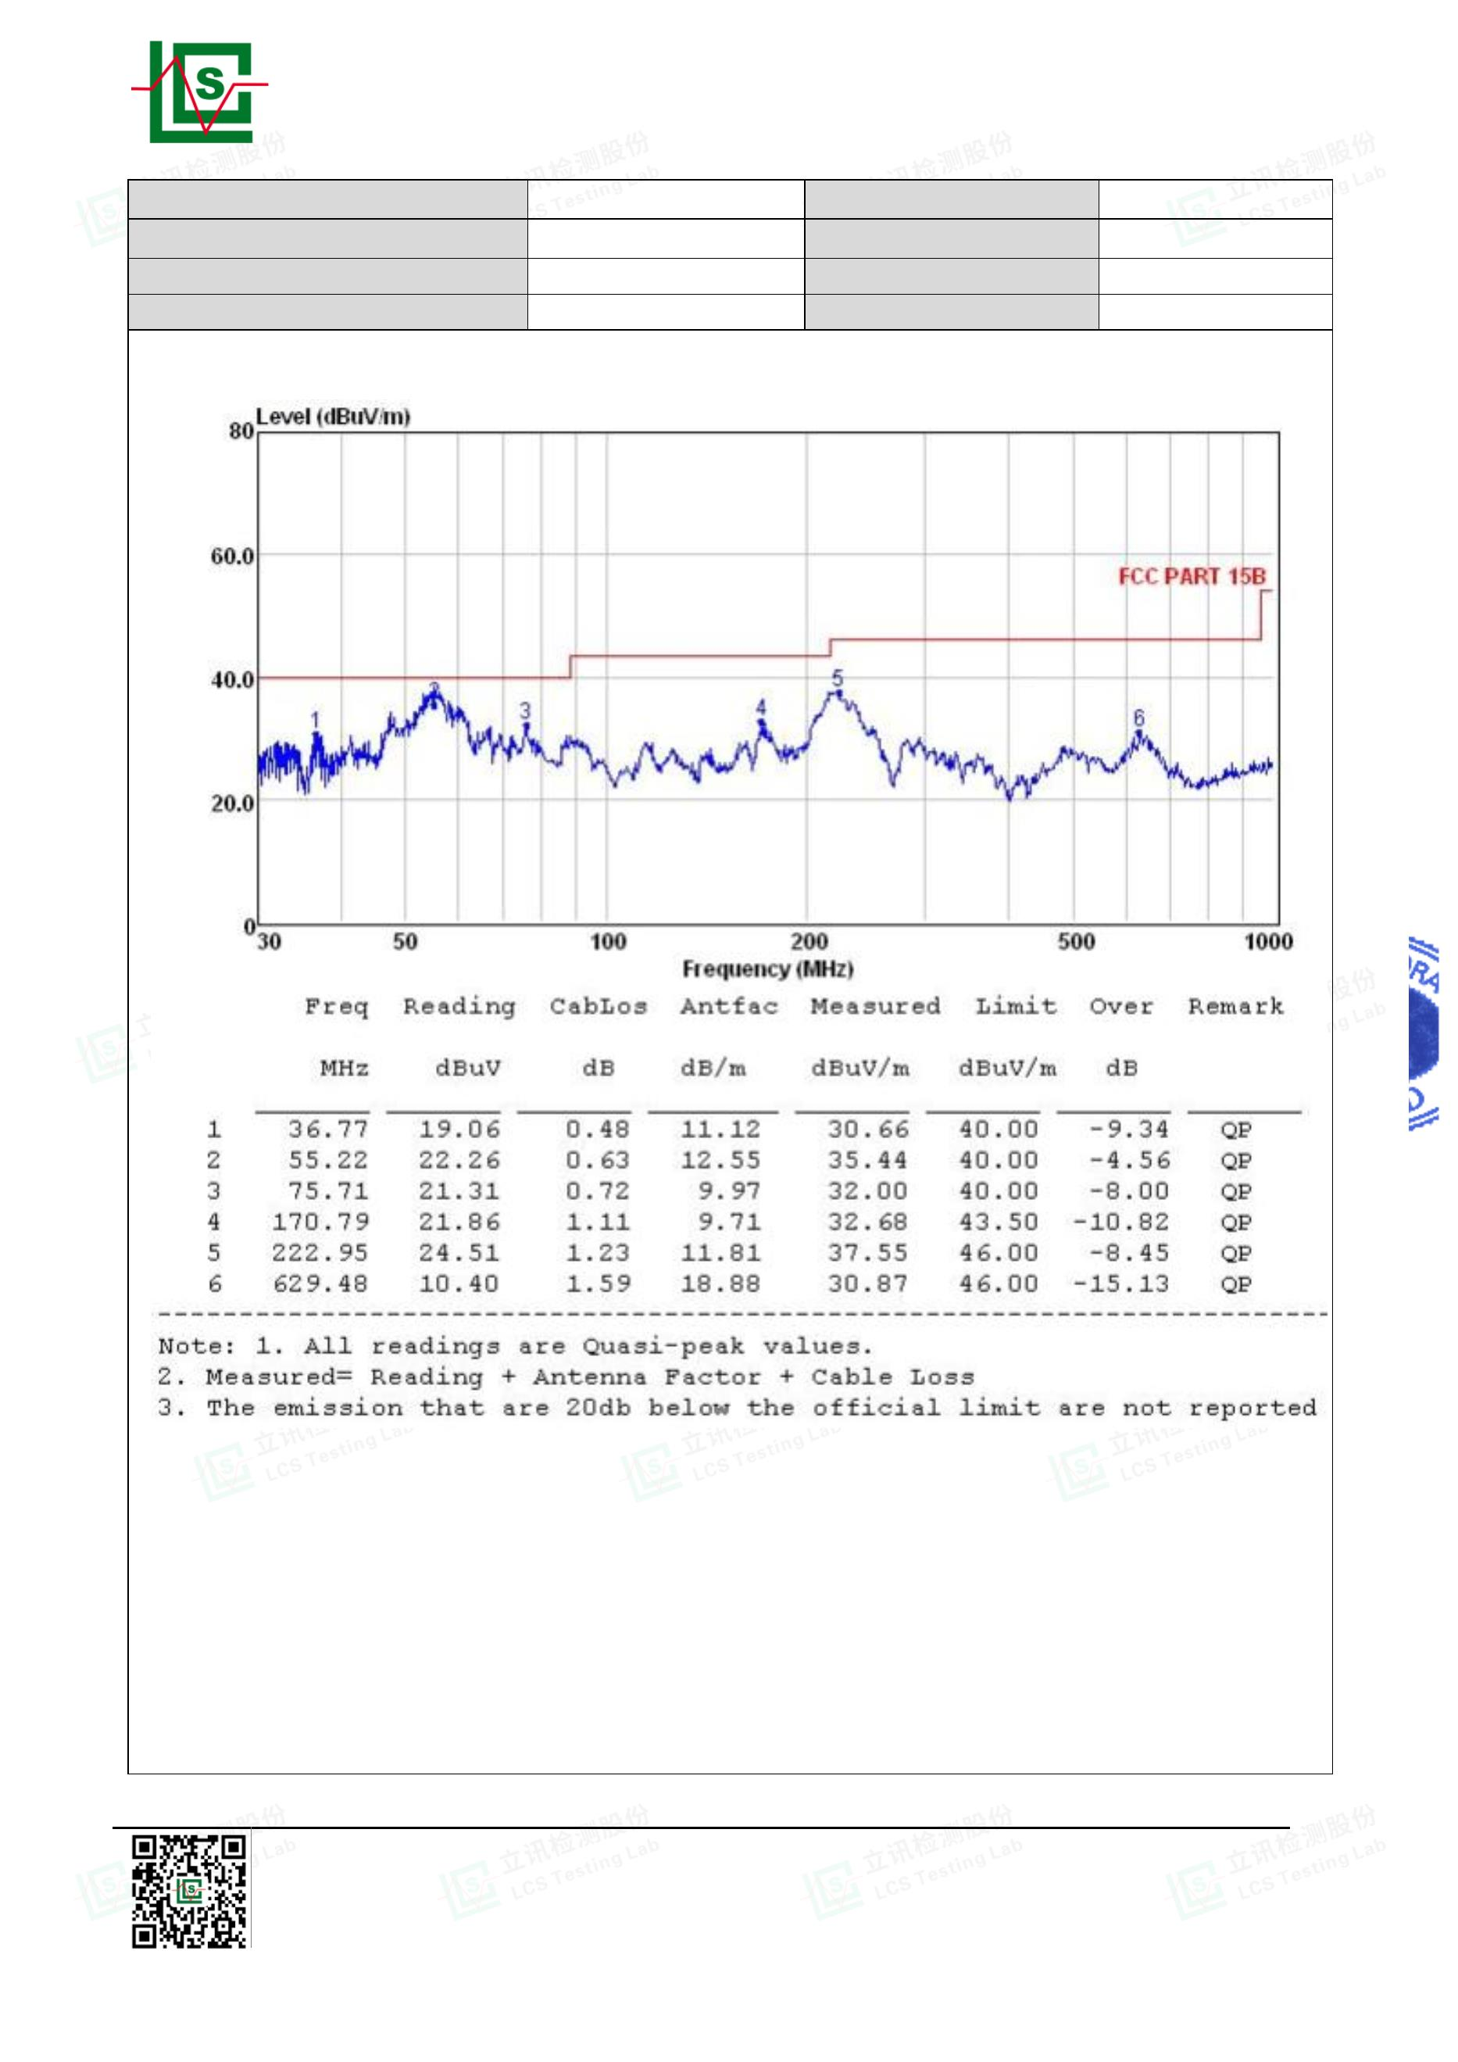

Page 17 of 32
Report No.: LCSA022723066E001
Test Model
CAT797
Test Mode
Mode 1
Environmental Conditions 22.3℃, 53 % RH
Detector Function Quasi-peak
Pol
Horizontal
Xf Peng
Distance
Test Voltage
3m
Test Engineer
AC 120V/60Hz
Note: Pre-Scan all mode, Thus record worse case mode result in this report.
Remark: For above 1000MHz, Because the emission it too low to be reported.
Shenzhen LCS Compliance Testing Laboratory Ltd.
Add: Room 101, 201, Building A and Room 301, Building C, Juji Industrial Park, Yabianxueziwei, Shajing Street,
Bao'an District, Shenzhen, Guangdong, China
Tel: +(86) 0755-82591330 | E-mail: webmaster@lcs-cert.com | Web: www.lcs-cert.com
Scan code to check authenticity
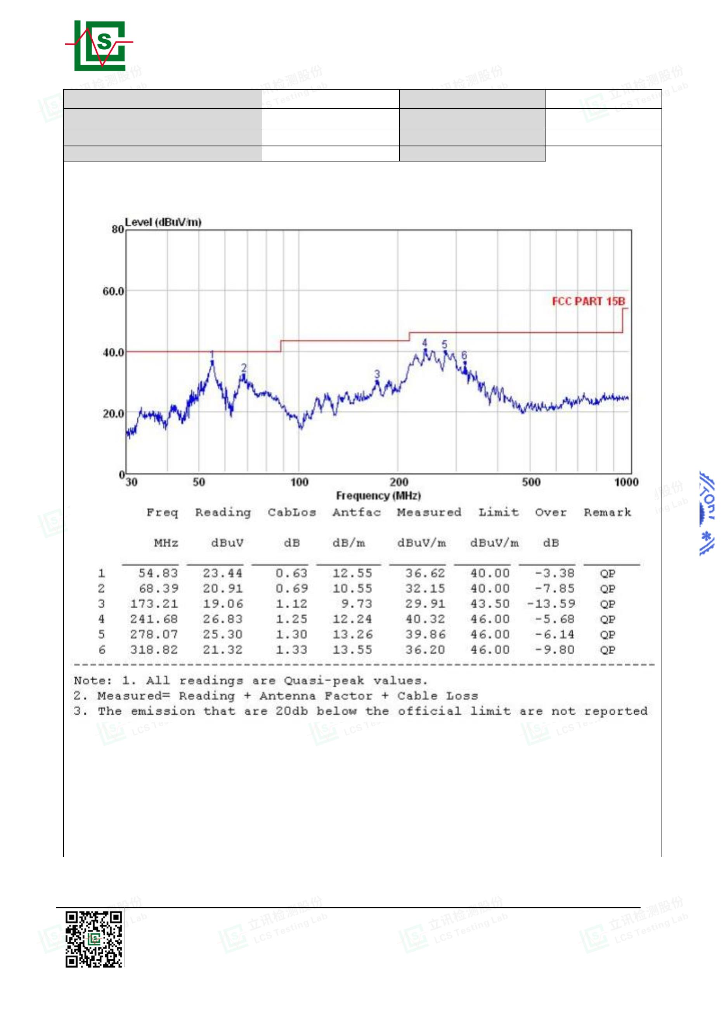

Page 18 of 32
Report No.: LCSA022723066E001
Test Model
CAT797
Test Mode
Mode 2
Environmental Conditions 22.3℃, 53 % RH
Detector Function Quasi-peak
Pol
Vertical
Xf Peng
Distance
Test Voltage
3m
DC
Test Engineer
Shenzhen LCS Compliance Testing Laboratory Ltd.
Add: Room 101, 201, Building A and Room 301, Building C, Juji Industrial Park, Yabianxueziwei, Shajing Street,
Bao'an District, Shenzhen, Guangdong, China
Tel: +(86) 0755-82591330 | E-mail: webmaster@lcs-cert.com | Web: www.lcs-cert.com
Scan code to check authenticity
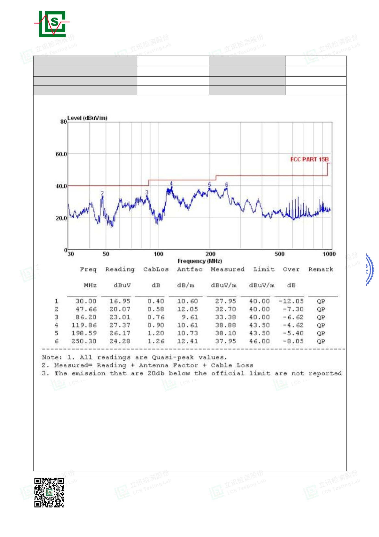

Page 19 of 32
Report No.: LCSA022723066E001
Test Model
CAT797
Test Mode
Mode 2
Environmental Conditions 22.3℃, 53 % RH
Detector Function Quasi-peak
Pol
Horizontal
Xf Peng
Distance
Test Voltage
3m
DC
Test Engineer
Note: Pre-Scan all mode, Thus record worse case mode result in this report.
Remark: For above 1000MHz, Because the emission it too low to be reported.
Shenzhen LCS Compliance Testing Laboratory Ltd.
Add: Room 101, 201, Building A and Room 301, Building C, Juji Industrial Park, Yabianxueziwei, Shajing Street,
Bao'an District, Shenzhen, Guangdong, China
Tel: +(86) 0755-82591330 | E-mail: webmaster@lcs-cert.com | Web: www.lcs-cert.com
Scan code to check authenticity
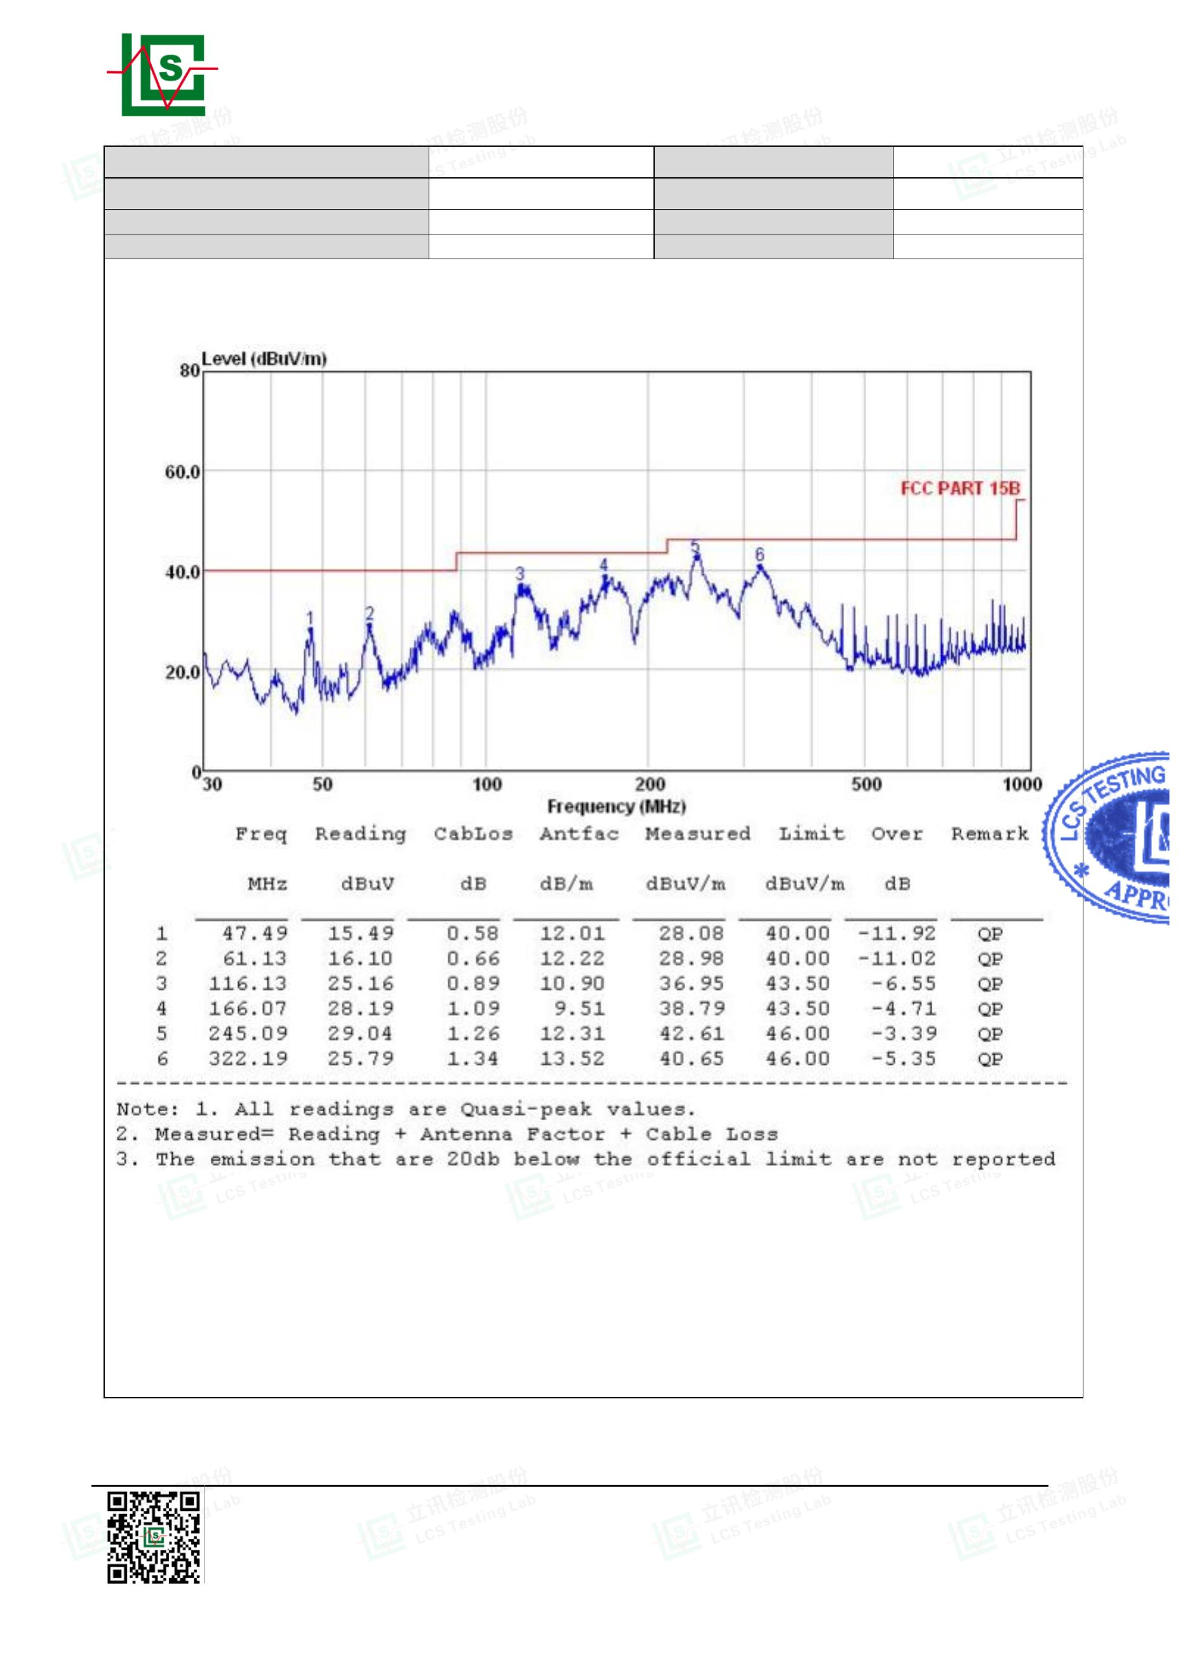

Page 20 of 32
Report No.: LCSA022723066E001
Test Model
CAT797
Test Mode
Mode 2
Environmental Conditions 22.3℃, 53 % RH
Detector Function Quasi-peak
Pol
Vertical
Xing Mo
DC 12V
Distance
Test Voltage
3m
DC
Test Engineer
Note
Shenzhen LCS Compliance Testing Laboratory Ltd.
Add: Room 101, 201, Building A and Room 301, Building C, Juji Industrial Park, Yabianxueziwei, Shajing Street,
Bao'an District, Shenzhen, Guangdong, China
Tel: +(86) 0755-82591330 | E-mail: webmaster@lcs-cert.com | Web: www.lcs-cert.com
Scan code to check authenticity
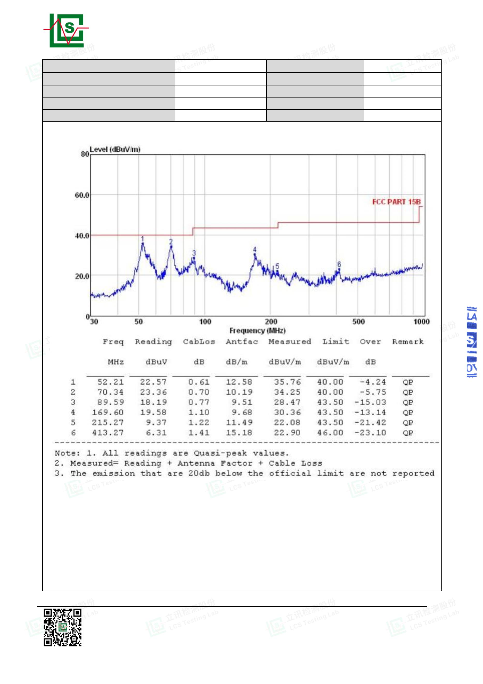

Page 21 of 32
Report No.: LCSA022723066E001
Test Model
CAT797
Test Mode
Mode 2
Environmental Conditions 22.3℃, 53 % RH
Detector Function Quasi-peak
Pol
Horizontal
Xing Mo
DC 12V
Distance
Test Voltage
3m
DC
Test Engineer
Note
Note: Pre-Scan all mode, Thus record worse case mode result in this report.
Remark: For above 1000MHz, Because the emission it too low to be reported.
Shenzhen LCS Compliance Testing Laboratory Ltd.
Add: Room 101, 201, Building A and Room 301, Building C, Juji Industrial Park, Yabianxueziwei, Shajing Street,
Bao'an District, Shenzhen, Guangdong, China
Tel: +(86) 0755-82591330 | E-mail: webmaster@lcs-cert.com | Web: www.lcs-cert.com
Scan code to check authenticity
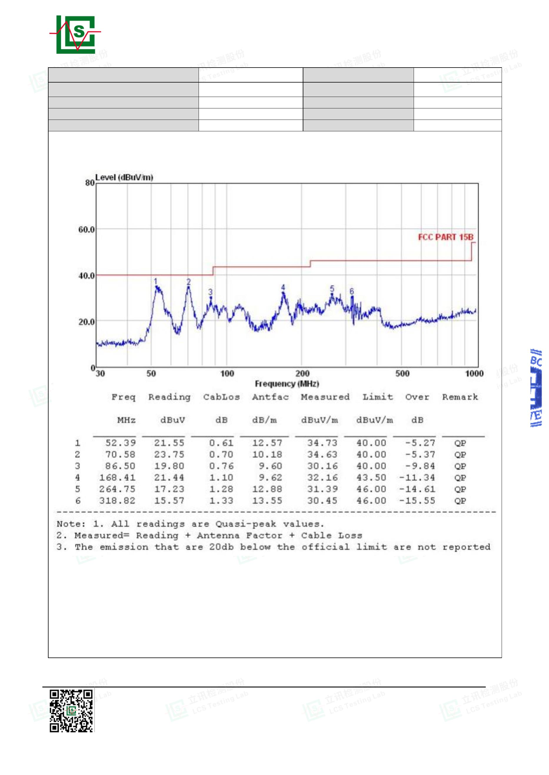

Page 22 of 32
Report No.: LCSA022723066E001
Test Model
CAT797
Test Mode
Mode 2
Environmental Conditions 22.3℃, 53 % RH
Detector Function Quasi-peak
Pol
Vertical
Xing Mo
USB-A
Distance
Test Voltage
3m
DC
Test Engineer
Note
Shenzhen LCS Compliance Testing Laboratory Ltd.
Add: Room 101, 201, Building A and Room 301, Building C, Juji Industrial Park, Yabianxueziwei, Shajing Street,
Bao'an District, Shenzhen, Guangdong, China
Tel: +(86) 0755-82591330 | E-mail: webmaster@lcs-cert.com | Web: www.lcs-cert.com
Scan code to check authenticity
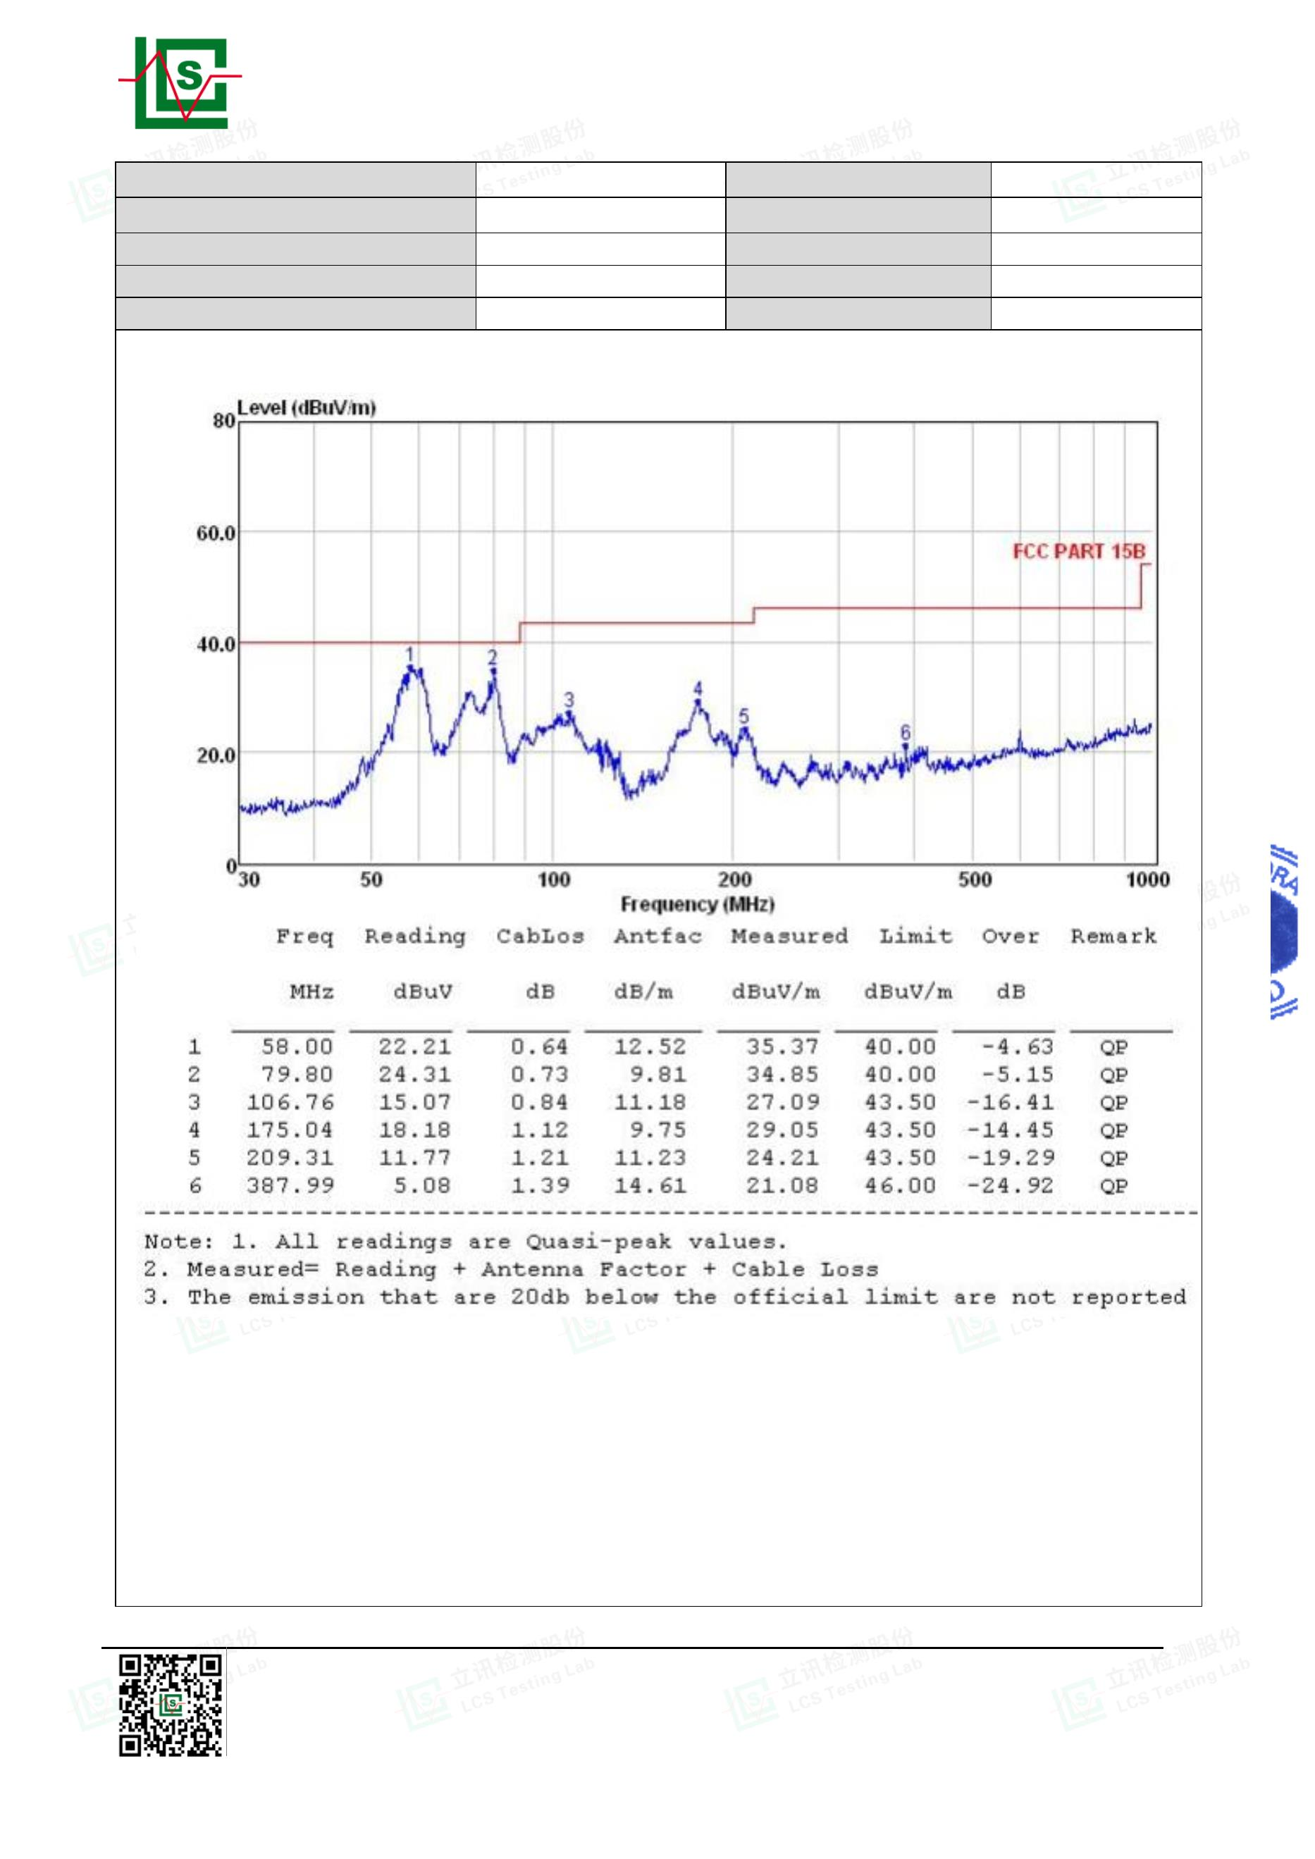

Page 23 of 32
Report No.: LCSA022723066E001
Test Model
CAT797
Test Mode
Mode 2
Environmental Conditions 22.3℃, 53 % RH
Detector Function Quasi-peak
Pol
Horizontal
Xing Mo
USB-A
Distance
Test Voltage
3m
DC
Test Engineer
Note
Note: Pre-Scan all mode, Thus record worse case mode result in this report.
Remark: For above 1000MHz, Because the emission it too low to be reported.
Shenzhen LCS Compliance Testing Laboratory Ltd.
Add: Room 101, 201, Building A and Room 301, Building C, Juji Industrial Park, Yabianxueziwei, Shajing Street,
Bao'an District, Shenzhen, Guangdong, China
Tel: +(86) 0755-82591330 | E-mail: webmaster@lcs-cert.com | Web: www.lcs-cert.com
Scan code to check authenticity
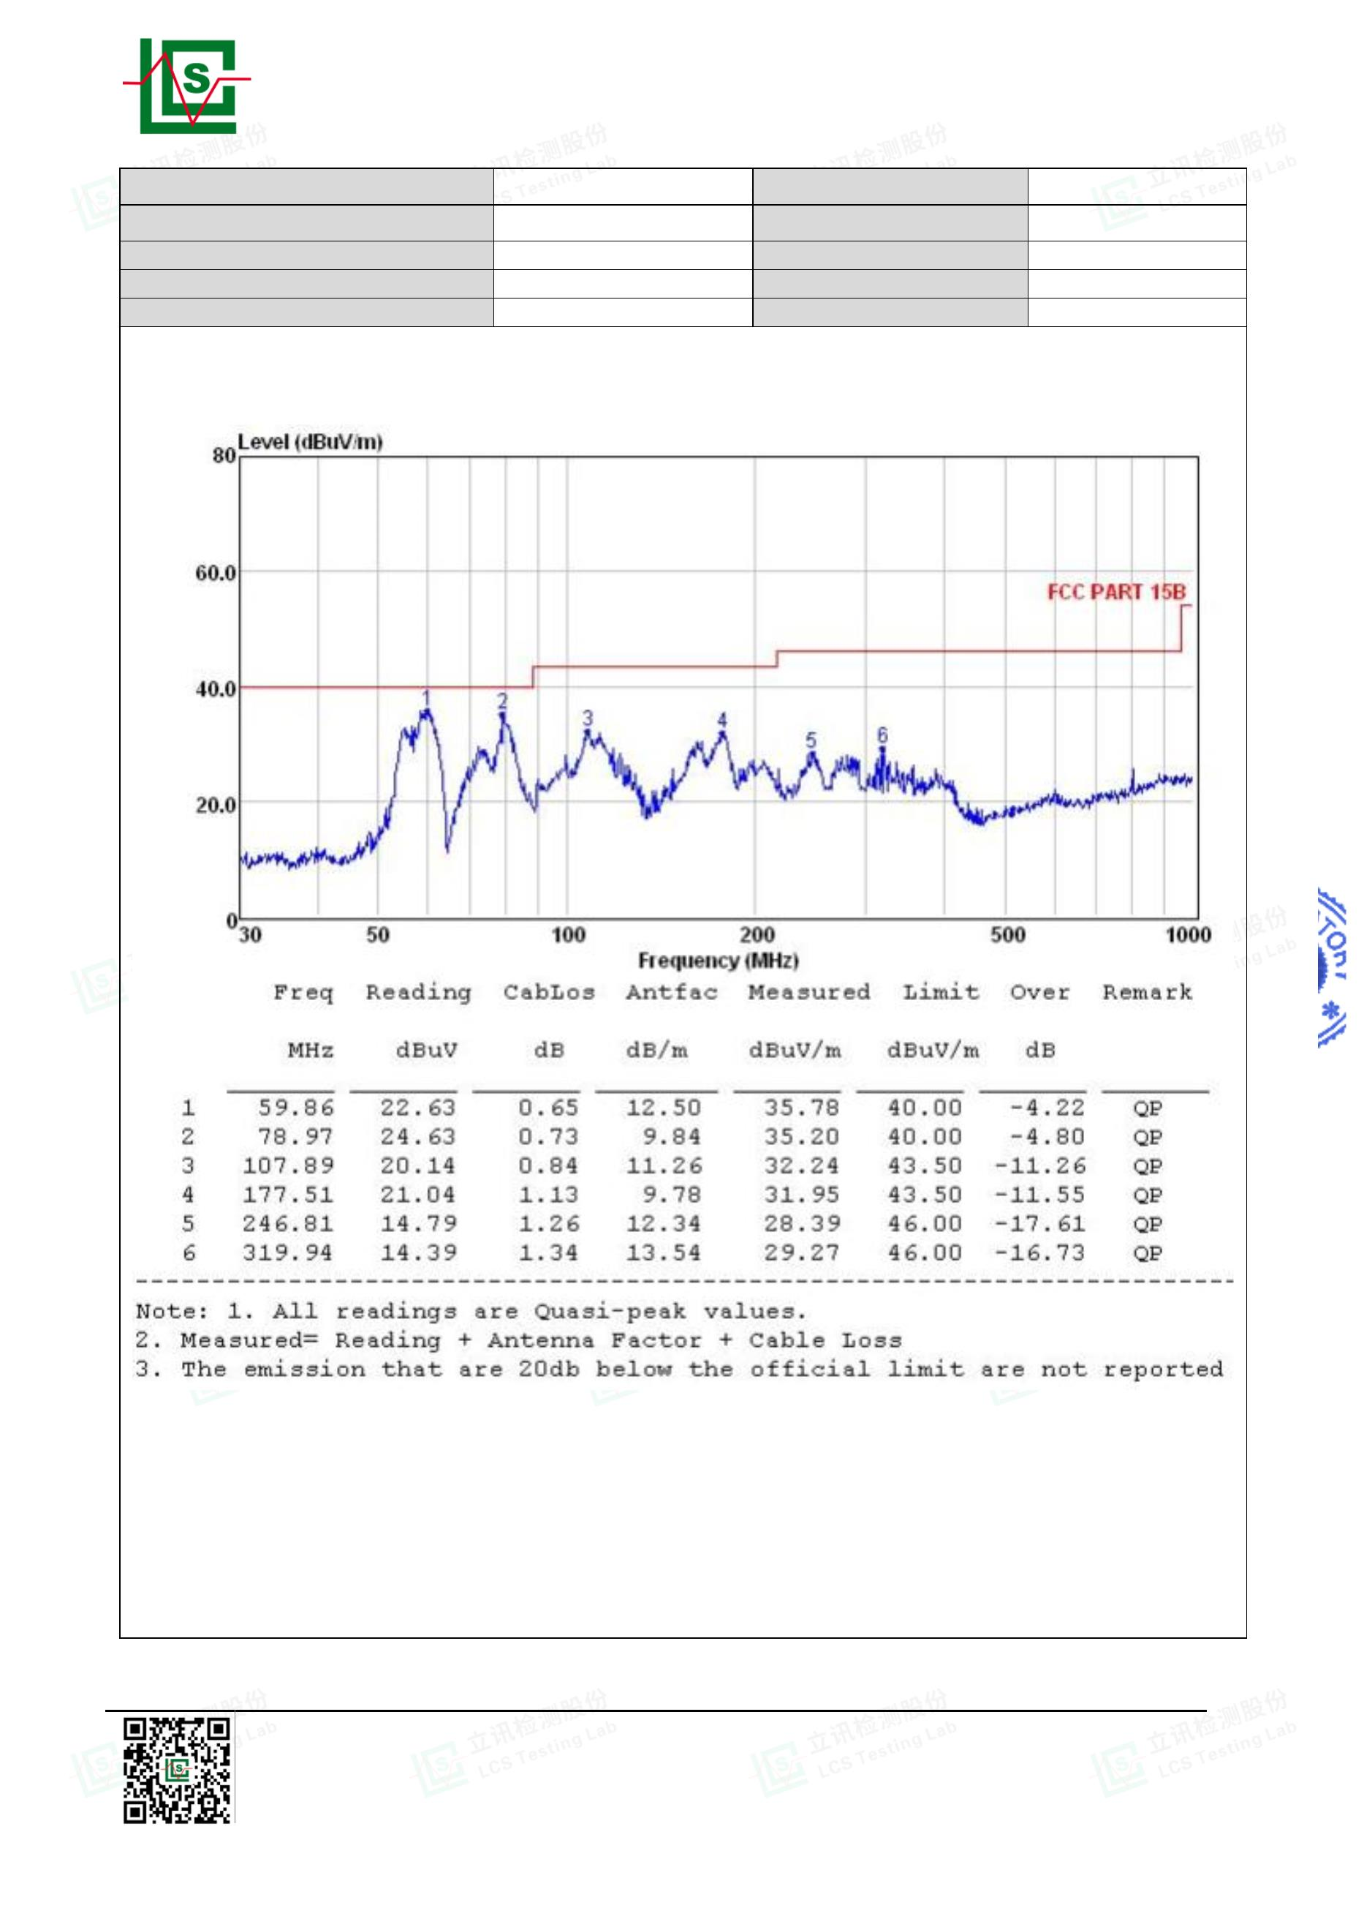

Page 24 of 32
Report No.: LCSA022723066E001
Test Model
CAT797
Test Mode
Mode 2
Environmental Conditions 22.3℃, 53 % RH
Detector Function Quasi-peak
Pol
Vertical
Xing Mo
USB-C
Distance
Test Voltage
3m
DC
Test Engineer
Note
Shenzhen LCS Compliance Testing Laboratory Ltd.
Add: Room 101, 201, Building A and Room 301, Building C, Juji Industrial Park, Yabianxueziwei, Shajing Street,
Bao'an District, Shenzhen, Guangdong, China
Tel: +(86) 0755-82591330 | E-mail: webmaster@lcs-cert.com | Web: www.lcs-cert.com
Scan code to check authenticity
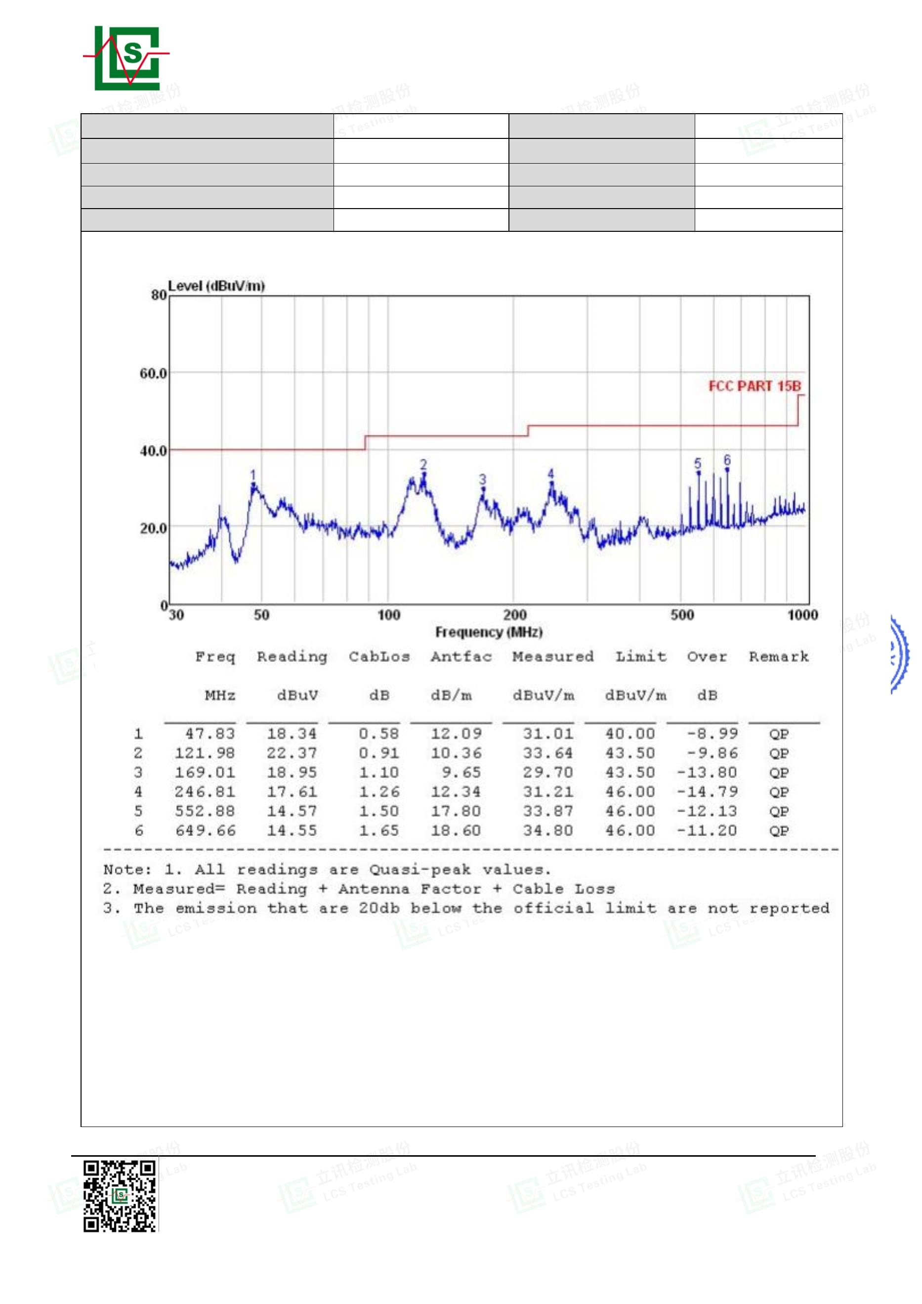

Page 25 of 32
Report No.: LCSA022723066E001
Test Model
CAT797
Test Mode
Mode 2
Environmental Conditions 22.3℃, 53 % RH
Detector Function Quasi-peak
Pol
Horizontal
Xing Mo
USB-C
Distance
Test Voltage
3m
DC
Test Engineer
Note
Note: Pre-Scan all mode, Thus record worse case mode result in this report.
Remark: For above 1000MHz, Because the emission it too low to be reported.
Shenzhen LCS Compliance Testing Laboratory Ltd.
Add: Room 101, 201, Building A and Room 301, Building C, Juji Industrial Park, Yabianxueziwei, Shajing Street,
Bao'an District, Shenzhen, Guangdong, China
Tel: +(86) 0755-82591330 | E-mail: webmaster@lcs-cert.com | Web: www.lcs-cert.com
Scan code to check authenticity
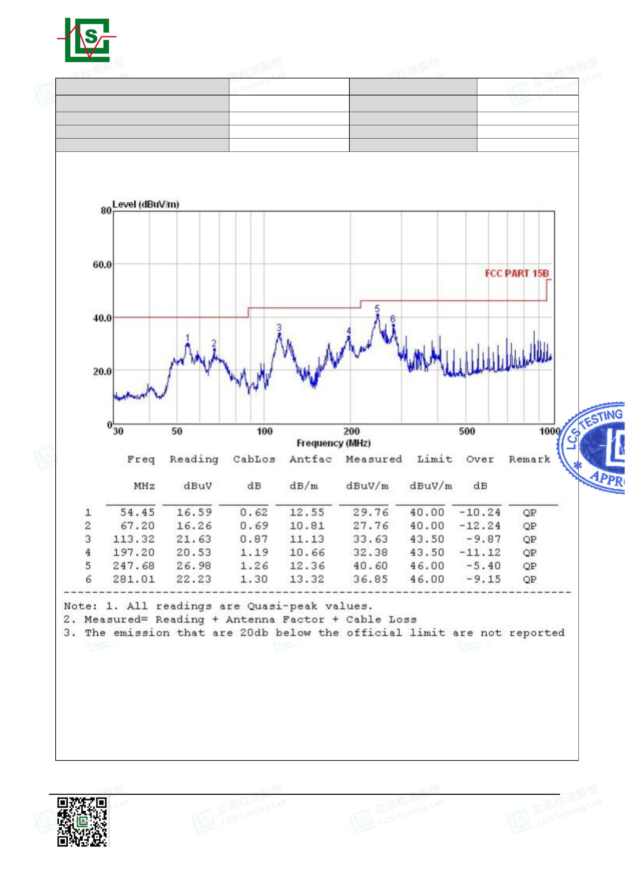

Page 26 of 32
Report No.: LCSA022723066E001
4. PHOTOGRAPH
Photo of Power Line Conducted Measurement
Photo of Radiated emission Measurement(Mode 1)
Shenzhen LCS Compliance Testing Laboratory Ltd.
Add: Room 101, 201, Building A and Room 301, Building C, Juji Industrial Park, Yabianxueziwei, Shajing Street,
Bao'an District, Shenzhen, Guangdong, China
Tel: +(86) 0755-82591330 | E-mail: webmaster@lcs-cert.com | Web: www.lcs-cert.com
Scan code to check authenticity
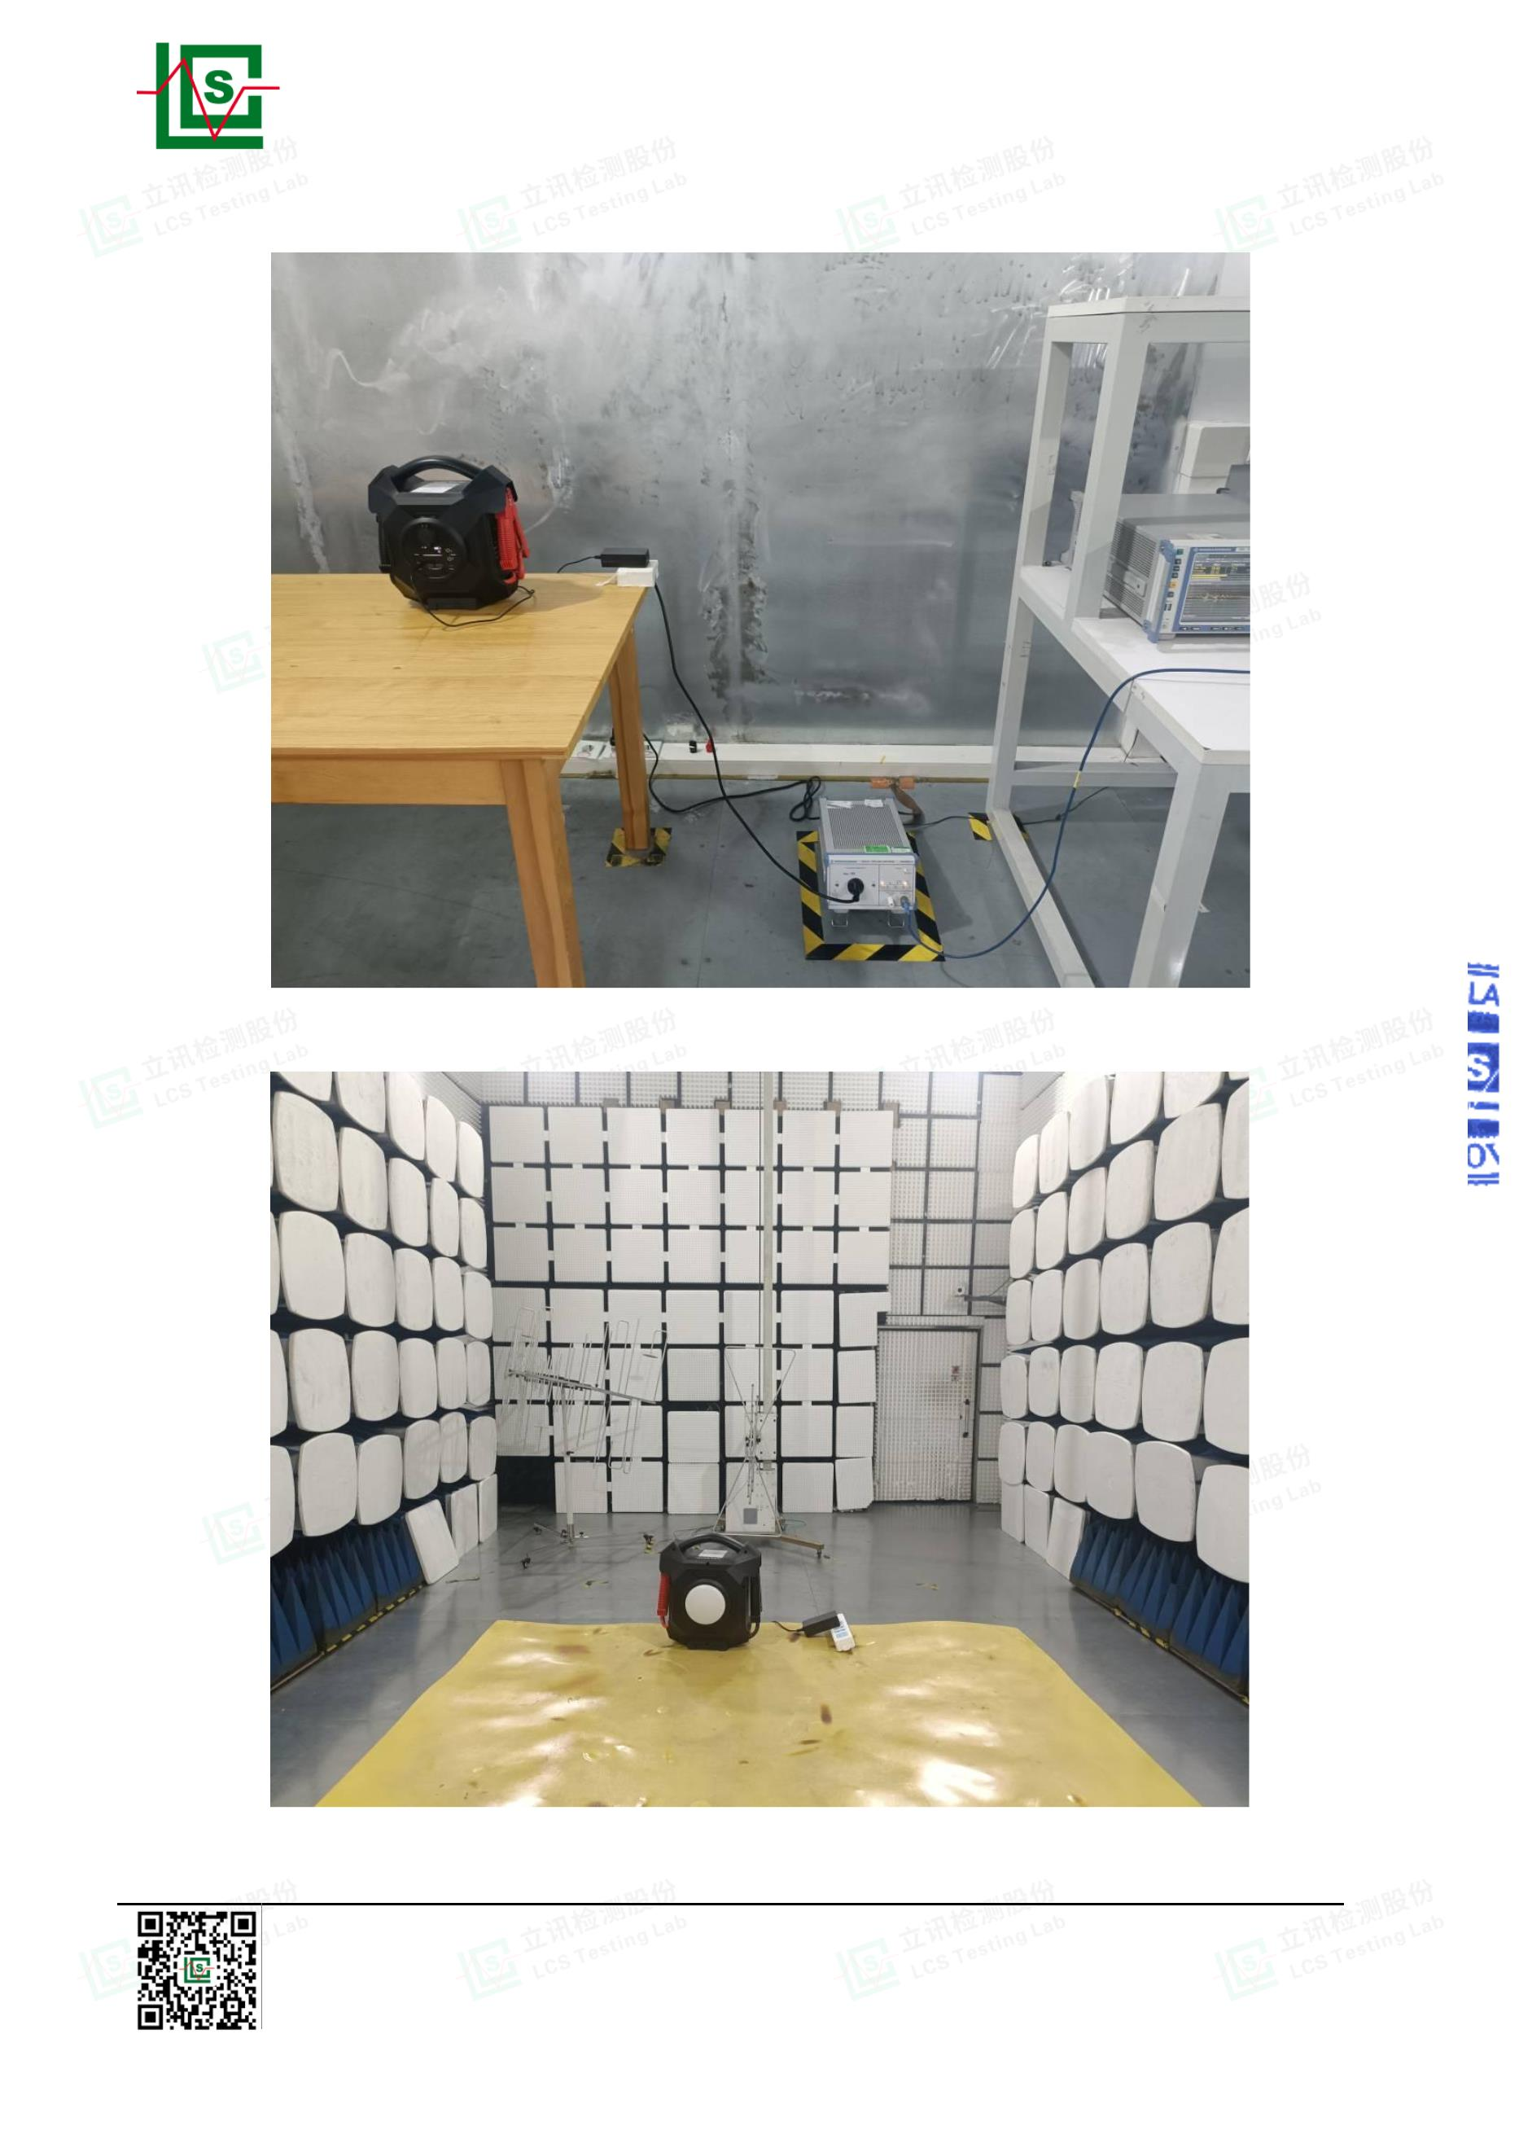

Page 27 of 32
Report No.: LCSA022723066E001
Photo of Radiated emission Measurement(Mode 2)
Shenzhen LCS Compliance Testing Laboratory Ltd.
Add: Room 101, 201, Building A and Room 301, Building C, Juji Industrial Park, Yabianxueziwei, Shajing Street,
Bao'an District, Shenzhen, Guangdong, China
Tel: +(86) 0755-82591330 | E-mail: webmaster@lcs-cert.com | Web: www.lcs-cert.com
Scan code to check authenticity
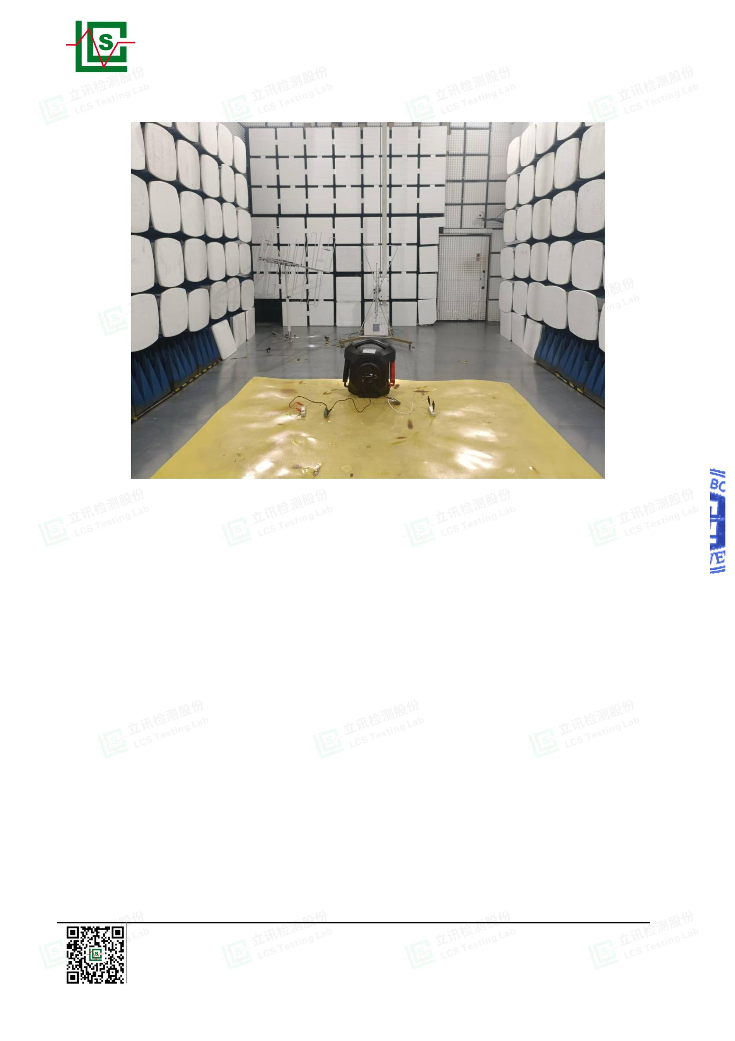

Page 28 of 32
Report No.: LCSA022723066E001
5. EXTERNAL AND INTERNAL PHOTOS OF THE EUT
Fig. 1
Fig. 2
Shenzhen LCS Compliance Testing Laboratory Ltd.
Add: Room 101, 201, Building A and Room 301, Building C, Juji Industrial Park, Yabianxueziwei, Shajing Street,
Bao'an District, Shenzhen, Guangdong, China
Tel: +(86) 0755-82591330 | E-mail: webmaster@lcs-cert.com | Web: www.lcs-cert.com
Scan code to check authenticity
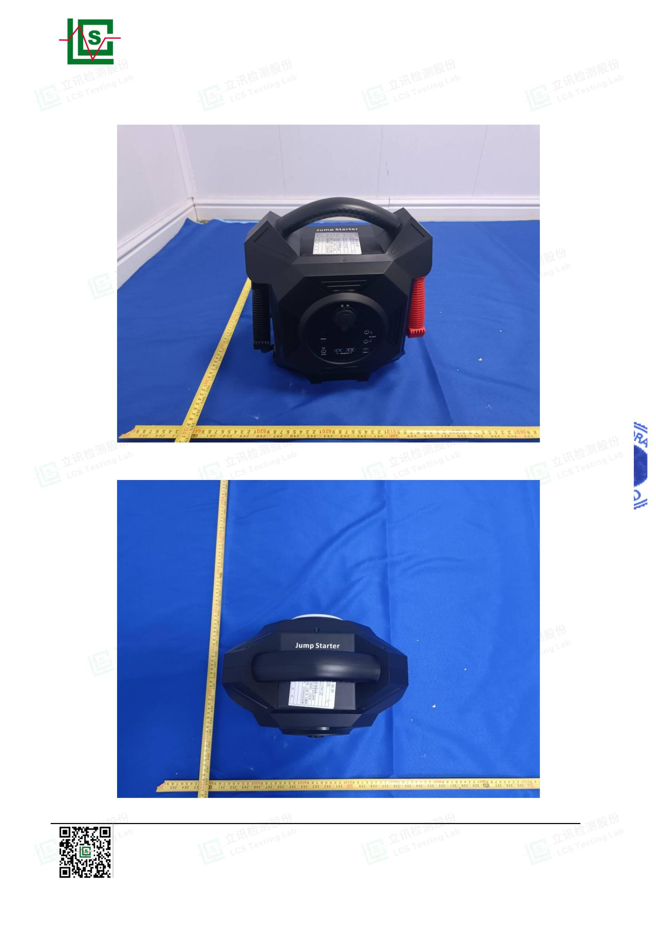

Page 29 of 32
Report No.: LCSA022723066E001
Fig. 3
Fig. 4
Shenzhen LCS Compliance Testing Laboratory Ltd.
Add: Room 101, 201, Building A and Room 301, Building C, Juji Industrial Park, Yabianxueziwei, Shajing Street,
Bao'an District, Shenzhen, Guangdong, China
Tel: +(86) 0755-82591330 | E-mail: webmaster@lcs-cert.com | Web: www.lcs-cert.com
Scan code to check authenticity
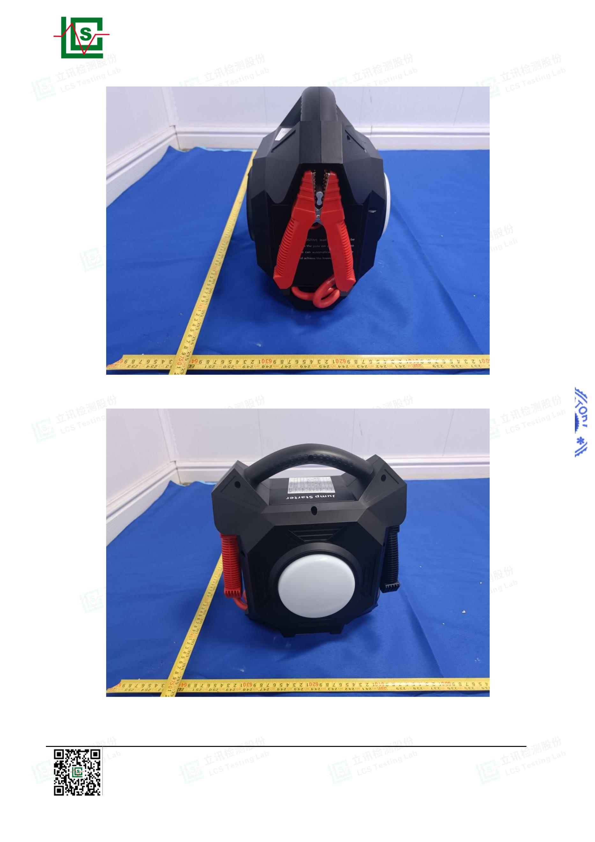

Page 30 of 32
Report No.: LCSA022723066E001
Fig. 5
Fig. 6
Shenzhen LCS Compliance Testing Laboratory Ltd.
Add: Room 101, 201, Building A and Room 301, Building C, Juji Industrial Park, Yabianxueziwei, Shajing Street,
Bao'an District, Shenzhen, Guangdong, China
Tel: +(86) 0755-82591330 | E-mail: webmaster@lcs-cert.com | Web: www.lcs-cert.com
Scan code to check authenticity
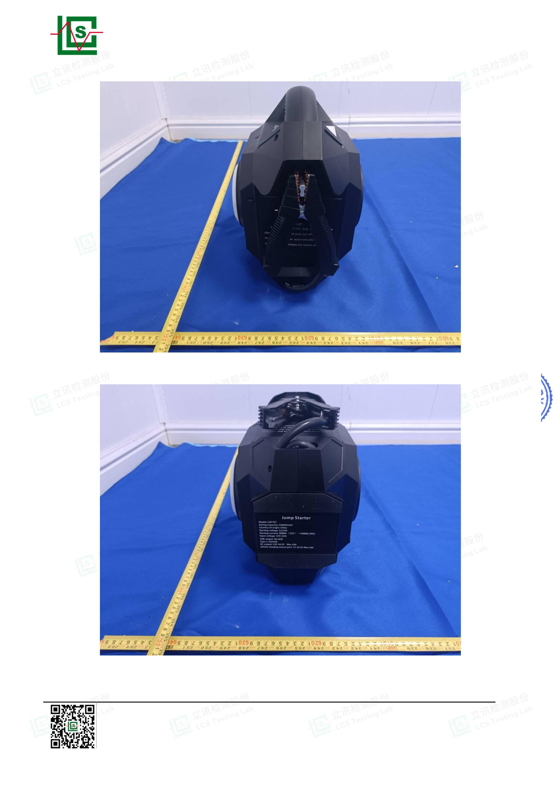

Page 31 of 32
Report No.: LCSA022723066E001
Fig. 7
Fig. 8
Shenzhen LCS Compliance Testing Laboratory Ltd.
Add: Room 101, 201, Building A and Room 301, Building C, Juji Industrial Park, Yabianxueziwei, Shajing Street,
Bao'an District, Shenzhen, Guangdong, China
Tel: +(86) 0755-82591330 | E-mail: webmaster@lcs-cert.com | Web: www.lcs-cert.com
Scan code to check authenticity
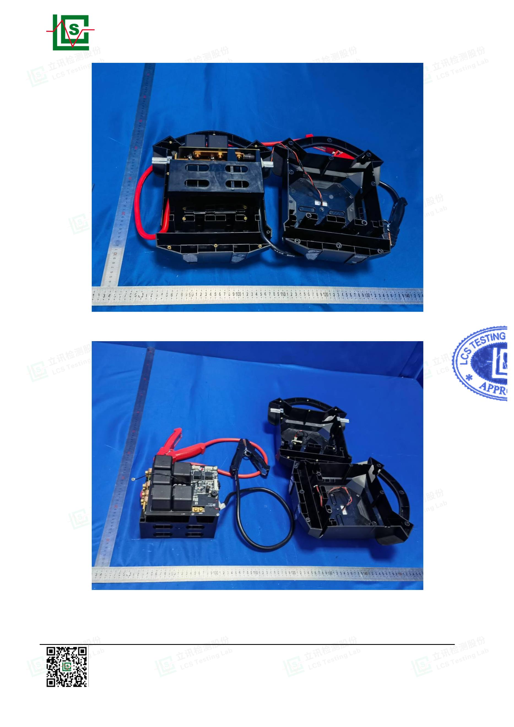

Page 32 of 32
Report No.: LCSA022723066E001
Fig. 9
Fig. 10
-----------------THE END OF TEST REPORT-------------
Shenzhen LCS Compliance Testing Laboratory Ltd.
Add: Room 101, 201, Building A and Room 301, Building C, Juji Industrial Park, Yabianxueziwei, Shajing Street,
Bao'an District, Shenzhen, Guangdong, China
Tel: +(86) 0755-82591330 | E-mail: webmaster@lcs-cert.com | Web: www.lcs-cert.com
Scan code to check authenticity
